NSW Education Standards Authority | 
Mathematics K–10 (2022)
Syllabus Support
curriculum.nsw.edu.au
Generated Dec 2025
Downloaded December 2025
© 2025 NSW Education Standards Authority
NESA acknowledges Traditional Owners and Custodians of Country throughout NSW, and pays respect to Elders past and present. NESA recognises Aboriginal Peoples’ continuing Cultures and Connections to lands, waters, skies and Community.
The documents on the NSW Education Standards Authority (NESA) website and the NSW Curriculum website contain material prepared by NESA for and on behalf of the Crown in right of the State of New South Wales. The material is protected by Crown copyright.
These websites hold the only official and up-to-date versions of the documents available on the internet. Any other copies of these documents, or parts of these documents, that may be found elsewhere on the internet might not be current and are not authorised. You cannot rely on copies from any other source.
All rights are reserved. No part of the material may be:
- reproduced in Australia or in any other country by any process, electronic or otherwise, in any material form
- transmitted to any other person or stored electronically in any form without the written permission of NESA except as permitted by the Copyright Act 1968 (Cth).
When you access the material, you agree:
- to use the material for research or study, criticism or review, reporting news and parody or satire
- to use the material for information purposes only
- not to modify the material or any part of the material without the written permission of NESA
- to reproduce a single copy for personal bona fide study use only and not to reproduce any major extract or the entire material without the permission of NESA
- to include this copyright notice in any copy made
- to acknowledge that NESA is the source of the material.
The documents may include third-party copyright material such as photos, diagrams, quotations, cartoons and artworks. This material is protected by Australian and international copyright laws and may not be reproduced or transmitted in any format without the copyright owner’s permission. Unauthorised reproduction, transmission or commercial use of such copyright material may result in prosecution.
NESA has made all reasonable attempts to locate the owners of third-party copyright material. NESA invites anyone from whom permission has not been sought to contact the Copyright Officer.
Special arrangements applying to the NSW Curriculum Reform
As part of the NSW Curriculum Reform process, NESA grants a limited non-exclusive licence to:
- teachers employed in NSW government schools and registered non-government schools
- representatives from peak school education bodies, such as the NSW Department of Education, Catholic Schools NSW, the Association of Independent Schools of NSW and TAFE NSW
- parents of children registered for home schooling
to use, modify and adapt the NSW syllabuses for non-commercial educational use only. The adaptation must not have the effect of bringing NESA into disrepute.
Note: The above arrangements do not apply to private/home tutoring companies, professional learning service providers, publishers, and other organisations.
For more information on the above or for commercial use or any other purpose, please contact the Copyright Officer for permission.
Email: copyright@nesa.nsw.edu.au

Table of contents
Table of contents 4
Mathematics K–10 (2022) 5
Teaching advice for Stage 2 5
Teaching advice for Representing numbers using place value A 5
Teaching advice for Representing numbers using place value B 8
Teaching advice for Additive relations A 11
Teaching advice for Additive relations B 15
Teaching advice for Multiplicative relations A 24
Teaching advice for Multiplicative relations B 29
Teaching advice for Partitioned fractions A 32
Teaching advice for Partitioned fractions B 35
Teaching advice for Geometric measure A 38
Teaching advice for Geometric measure B 41
Teaching advice for Two-dimensional spatial structure A 43
Teaching advice for Two-dimensional spatial structure B 46
Teaching advice for Three-dimensional spatial structure A 49
Teaching advice for Three-dimensional spatial structure B 52
Teaching advice for Non-spatial measure A 54
Teaching advice for Non-spatial measure B 57
Teaching advice for Data A 58
Teaching advice for Data B 61
Teaching advice for Chance A 63
Teaching advice for Chance B 65
Glossary 67
Mathematics K–10 (2022) Terms 67
Global Terms 104

Mathematics K–10 (2022)

Teaching advice for Stage 2

Teaching advice for Representing numbers using place value A

Content
- Representing numbers using place value A

Teaching advice
Understanding place value requires more than naming the ones place, tens place and hundreds place. Students may need multiple opportunities to establish the relationship between the place value of digits in various numerals.
For example, the '5' in 35 represents 5 ones, but the '5' in 53 represents 50 or 5 tens. That is, the '5' in 53 represents 10 times the value of the '5' in 35. Students often initially view each digit in a 2-digit number as representing ‘ones’.
The transition from using the language ‘groups of ten’ in K–2 to referring to ‘tens’ as abstract units, relies on students recognising that a ten is a group of 10 ones. Bundling groups of ten sticks or similar objects when representing 2-digit numbers can provide a context for transitioning language from ‘groups of ten’ to ‘tens’. Some students may find ten-frames and place-value charts useful supports (Hartnett 2018).
The place value numeration system is based on two inseparable principles (Ross 1989):
- the positional principle – the position of each digit in a written number corresponds to a unit eg hundreds stand in the third place
- the decimal principle – each unit is equal to ten units of the immediately lower order eg one hundred = 10 tens.
It is important that students have opportunities to establish the relationship between ones, tens and hundreds before progressing to non-standard forms of partitioning. The relationship between ones, tens and hundreds is the basis of the place value grouping structure.
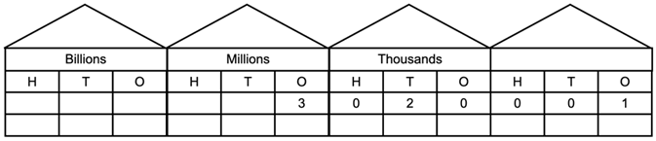
Figure 1: Place value structure of ones, tens and hundreds

The quantity value of 3 in 1234 is clear when we read it as ‘one thousand two hundred and thirty-four’. The multiplicative property of place value (Ross 2002) means that the quantity value of a digit is found by multiplying the face value of the digit (3) by the value of its position (ten).
Place value understanding needs to be explicitly developed in a range of contexts involving representing and operating with multidigit numbers.

The dual role of zero in numerals
The introduction of zero into our number system has its own history (Joseph 2008).
Zero is a symbol, a number, a magnitude and a place holder in a positional number system.
Zeros in numerals can have two different roles:
- to name the number
- as place holders to parse the number into its component parts.
Any zeros at the end of whole numbers are known as lexical zeros, as they indicate the name of the number.
For example, 300 and 2000 use lexical zeros to signal the names ‘three hundred’ and ‘two thousand’.
Zeros at the end of a decimal can be described as ‘trailing zeros’ and are used to show precision in measurement.
Internal zeros in whole numbers can be described as syntactic zeros. They represent a null quantity for a specific power of ten.
Internal zeros are more difficult to interpret than lexical zeros eg 1002 is more difficult to interpret than 1000.
Students need opportunities to learn to read and name the component parts of numbers with internal zeros. Without clear guidance on reading numerals students may incorrectly read 1001 as ‘one hundred and one’, ‘one hundred and ten’ or ‘ten hundred and ten’ (Moura et al. 2021).
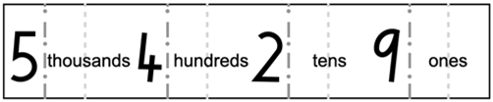
Figure 2: A number expander

Number expanders can assist students to understand place value and renaming numbers into non-standard forms. Some traditional number expanders and place value charts use the term ‘units’ instead of ‘ones’. The term ‘units’ is a more general term than ‘ones’. Units can be units of ‘one’ or units of ‘ten’ as well as referring to units of measurement.
Although both terms are correct, the term ‘ones’ can help reduce confusion with other meanings of units. That is, ‘10 ones equal 1 ten’ rather than ‘10 units equal 1 ten’.
Systematically moving the position of non-zero digits can provide practise in naming numbers.
For example, naming 1200, 1020, 1002 involves both lexical and syntactic zeros.

Wipe-out
Calculators can be effectively used with activities like Wipe-out (Board of Studies 1993). Ask students to enter a 3-digit or 4-digit number on the calculator, such as 3042. The task is to have the calculator show 3002 by taking away one number. Ask your students to show you how they did it and tell you the answer as a number, not a string of digits.

Language
In Australia, the word 'and' is used before the tens and ones positions when reading and writing a number in words, eg 3568 is read as 'three thousand, five hundred and sixty-eight' and 3008 is read as 'three thousand and eight’.

Vocabulary
Students should be provided with opportunities to develop confidence in using some or all of the following terms to communicate:
- number before
- number after
- more than
- greater than
- less than
- largest number
- smallest number
- digit
- zero
- ones
- groups of ten
- tens
- groups of one hundred
- hundreds
- groups of one thousand
- thousands
- place value.

Teaching advice for Representing numbers using place value B

Content
- Representing numbers using place value B

Teaching advice
We name 4-digit, 5-digit and 6-digit numbers as thousands eg, 3 thousand, 30 thousand, 300 thousand. The convention for writing numbers of more than 4 digits requires that numerals have a space, and not a comma, to the left of each group of 3 digits when counting from the ones column, eg 16 234. This is to assist in reading numbers.
No space is used in a 4-digit number as they are easy to read without a separator, eg 2004. Sometimes commas are used in numbers for on-screen text to support North American screen readers.
Different mathematics notations are used around the world. Even the numerals themselves are not the same everywhere. What is often described as Arabic or Hindu-Arabic numerals might best be thought of as Western numerals (Chrisomalis 2012). Using the terms Arabic and Hindu-Arabic to describe the set of signs 0, 1, 2, 3, 4, 5, 6, 7, 8, 9 does not distinguish them from the signs ٠,١,٢,٣,٤,٥,٦,٧,٨,٩ used in Arabic script or the set used in modern Devanagari script (०, १, २, ३, ४, ५, ६, ७, ८, ९). Some students may be familiar with more than one set of numerals.

Using arrow cards for expanded notation
It is important for students to develop a rich understanding of expanded notation and equivalence.
For example, 234 = 200 + 30 + 4 = 200 + 20 + 14 and 19 = 10 + 9. Finding the answer to 234 − 119 with exchanging one ten for ten ones then has a clear foundation.
Arrow cards can assist students in recognising how place value works when partitioning numbers. The arrow points are used to help align the cards when the smaller values are stacked on top of the higher values.
Figure 1. Stacking arrow cards to uncover place value structure

Using arrow cards, it is helpful to have students:
- explore the relationship between values eg how many tens are in 230?
- demonstrate that when they build a number, it contains its component parts eg in 34, the 30 is still there under the 4, it’s 30 + 4. Thirty is 3 tens; 34 is 3 tens plus 4
- create the same number with a familiar model, such as base-10 blocks, bead strings or bundles of craft sticks.
When children who have not been taught an algorithm were invited to find a way to add numbers, most will split the numbers into the place value components (Kamii 2004). Splitting the numbers into their place value components, combined with equivalence, creates a foundation for operating with numbers.

Multiplicative comparison
Multiplicative comparison eg ‘× times as large’ can be supported by using schematic representations such as diagrams (Figure 2) and displays or spatial models.
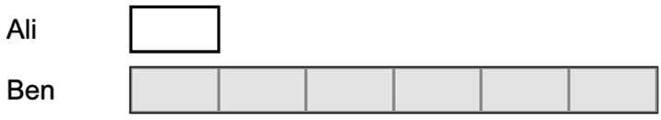
Figure 2: Representing Ben has 6 times as many as Ali

These representations can assist in the transition to understanding the abstract multiplicative relation between units.

Decimal notation
When introducing decimal notation, refer to tenths and hundredths using the words rather than the fraction notation. The fraction notation for tenths and hundredths does not use place value.
The primary purpose of the decimal point is to ‘show where the ones column is’.
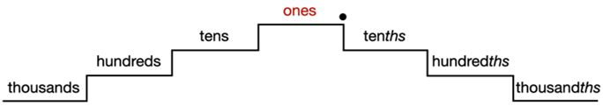
Figure 3: Representing the symmetry around the ‘ones’

The ones are the building blocks of the whole numbers.
The next place value column to the left of the ones column is created by grouping ten ones together. This process is repeated to get more place value columns further to the left.
To create the place value columns to the right of the ones column, we partition one into ten equal pieces. This process is repeated to get more place value columns further to the right (Steinle 2004).
That is, multiplying by ten creates the place value columns to the left of the ones column, and dividing by ten creates the place value columns to the right of the ones column.
The role of zero as a place holder assists in understanding how we say and write decimals.
For decimals less than one, zero is written in the ones place in a decimal to reduce the risk of misreading the decimal as a whole number.
The number 0.2 has the same value as 0.20 and the number 2 has the same value as 2.0.
(See further information on the role of zero in Representing numbers using place value A.)

Decimal misconceptions
Students often interpret decimal notation as a way of writing whole numbers separated by the decimal point. In a study involving over 1500 students in Norway, between 40% and 50% of students aged 11, 13 and 15 wrote 0.11 for eleven tenths (Brekke 1996).
When students first encounter decimals, the most common misconception identified is the belief that longer decimals are always larger decimals. A student who believes that longer decimals are always larger will indicate that 0.75 is larger than 0.8.
To reduce this misconception, establish the benchmark values ½ = 0.5 and ¼ = 0.25. Then prompt students to pay particular attention to the digit in the tenths place as shown on a length divided into tenths.
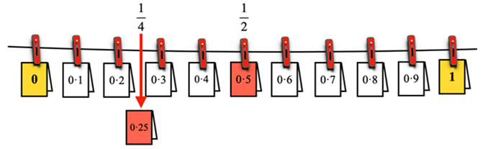
Figure 4. Locating 0.25 on a representation of a number line

Changing what students attend to with decimals by focusing their attention can lead to improvements in their decimal magnitude knowledge (Durkin and Rittle-Johnson 2015).
One of the challenges of addressing misconceptions when teaching decimals, is the movement between different misconceptions. The misconception that longer decimals are always larger decimals can over time be replaced by the opposite belief – that shorter decimals are always larger decimals. It is important to continue to check if students have any decimal misconceptions as they move through the Stages.
Many misconceptions associated with decimals are due to inappropriate analogies. A student comparing the decimal 0.3 to 0.4 might choose 0.3 as larger by some analogy with one third and one quarter (reciprocal thinking or ‘bigger makes smaller’) or negative three and negative four (negative thinking) (Stacey et al. 2001).
Steinle found that misconceptions associated with interpreting the decimal portion as a whole number (using whole number thinking, reciprocal thinking or negative thinking) are the hardest for students to leave behind (Steinle and Stacey 2004).

Teaching advice documents
- Teaching advice (additional): Stage 2 – Representing numbers using place value B (Language and Vocabulary) – Mathematics 3–6

Teaching advice for Additive relations A

Content
- Additive relations A

Teaching advice

The equals sign
The equals sign identifies a relationship in mathematics.
Students need to be provided with contexts to appreciate that the = sign is a statement of equality. For example, 4 + 1 = 3 + 2 means 4 + 1 'has the same value as' 3 + 2.
Gesturing when teaching can help students appreciate the 2 sides in an equality relationship.
For example:
‘I want to make one side, [sweeping left hand back and forth under the left side of the equality], equal to the other side, [sweeping right hand back and forth under the right side of the equality].’
Gesturing in this way can encourage students to produce similar gestures, which can aid learning.
A sequence of True or False equality statements can be used to encourage discussion in class.
For example, show each of the following statements one at a time and ask if this is true or false, and how do you know?
4 + 7 = 11
11 = 4 + 7
11 = 11
4 + 7 = 4 + 7
4 + 7 = 7 + 4
4 + 7 = 5 + 6
Emphasise that ‘=’ means ‘has the same value as’.
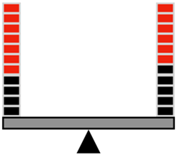
Figure 1: Balance showing equality of 7 + 4 and 6 + 5

Using an analogy of a balance can help some students broaden their understanding of equality.
Typically, students initially interpret the equals sign as an operational symbol meaning the answer or the total. This meaning has been found to change gradually to include interpreting it as a relational symbol of equivalence in certain contexts (McNeil and Alibali 2005).

Connecting addition and subtraction
If you add 2 numbers, the total is the sum of the parts. The additive relationship can be expressed as an equality, such as 45 + 23 = 68 or 68 = 45 + 23. This equality also highlights how addition is related to subtraction.
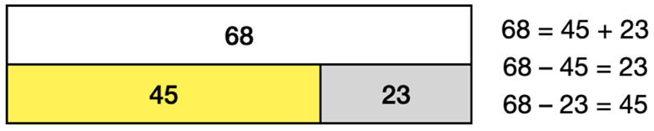
Figure 2: Bar model representing part-part-whole relationship

Knowing 45 and 23 add to 68 also means the difference between 68 and 45 is 23. The connection between addition and subtraction means that addition can be used to carry out subtraction.
To work out 68 − 45, think: How much must be added to 45 to make 68?
The principle of equality also means numbers can be partitioned in different ways, which can make some addition questions easier.
eg 500 + 670 is 670 = 500 + 170, so 500 + 670 = 500 + 500 + 170, which is 1000 + 170 = 1170.
The mental strategies students learn for addition and subtraction form the foundation for generalisable methods. Developing calculation methods that can be used with any numbers is an important component of number and algebra.

Developing a repertoire of strategies
In Stage 1, mental strategies progress from count-by-one methods, through counting-on, to using number bonds and bridging across multiples of ten. In Stage 2, students apply and extend their repertoire of mental strategies for addition and subtraction. The mental strategies are shared using models such as the bar model.

Different ways of representing models
Using number lines as a representation of additive relations is continued from Stage 1. Bar models and tape diagrams are also introduced in Stage 2 to assist students in appreciating and recognising the part-part-whole relationships when adding and subtracting. Representing the problems using bar diagrams can help reduce the load on working memory. Some students might need access to other forms of manipulatives to communicate or represent their learning.
Bar models and tape diagrams are very similar. A tape diagram looks like a single piece of tape and is used to show how quantities are related (Xiaobo and Harrington 2022).
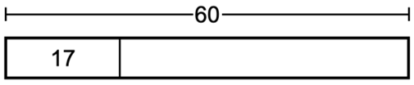
Figure 3: A tape diagram

Bar models can use separated rectangles rather than a single piece of tape.

Two additive uses of the bar model
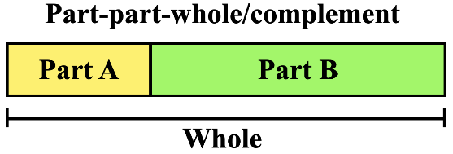

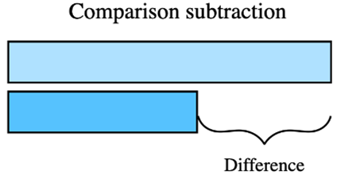
Figure 4: Using the bar model to compare parts of the whole

One of the advantages of using a bar model to consistently represent the information in a problem is that students know what kind of picture to create to show what is known, and it ‘shows the student how to use that information to solve the problem’ (Hoven & Garelick 2007:28).
The bar model forms a foundation for algebra in helping students to represent problems symbolically.

The complement principle of additive relations
Additive reasoning is based on quantities being connected to form the whole.
This additive connection generates 2 basic principles: commutativity and the complement principle.
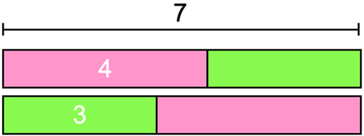
Figure 5: Bar model representing commutative property of addition

Commutativity refers to the order of addition not changing the result, 3 + 4 = 4 + 3.
The complement principle highlights the inverse relation between addition and subtraction.
That is, 3 + 4 = 7 implies 7 − 4 = 3 using the complement principle, or equally 7 − 3 = 4. An appreciation of commutativity appears to develop before making use of the complement principle (Ching and Nunes 2017).
The order in which these principles develop is likely influenced by students learning to count on from the larger number before learning to solve ‘missing addend’, or missing value, questions.
In symbols, 4 + □ = 10 is a missing addend question.
The strategy of counting on from the larger number relies on the commutative principle of addition, whereas the complement principle is used in solving ‘missing addend’ questions.

Using the complement principle with subtraction
The most challenging use of the complement principle is recognising that a – b = c means a – c = b. The number of steps of algebraic reasoning needed to appreciate why the two forms are equivalent makes substantial demands on working memory.
For example, 100 – 3 = 97 implies 100 – 97 = 3 because 97 + 3 = 100.
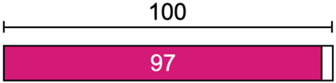
Figure 6: Using the bar model to represent the complement principle

Image long description: A diagram representing the complement principle used with subtraction. It shows the relation of the quantities 97 and 100.
This use of the complement principle requires recognising that when 2 numbers are added, subtracting either number from the total produces its complement, that is, the number required to make a group complete.

Teaching advice documents
- Teaching advice (additional): Stage 2 – Additive relations A (Strategies and Vocabulary) – Mathematics 3–6

Teaching advice for Additive relations B

Content
- Additive relations B

Teaching advice

Understanding equality
Finding the missing number in a number sentence involving operations on both sides of the equals sign relies on understanding equality and the meaning of the equals sign (Falkner et al. 1999).
In solving 8 + 4 = □ + 5 the answers of 12, 17 or even 12 and 17, are often more commonly provided than the correct answer.
Understanding that equality means 2 mathematical expressions hold the same value is essential to symbolic algebra. However, this relational meaning of the equals sign typically develops over a number of years.
Developing an understanding of the equals sign through discussion of True and False number sentences should be revisited.
Which of the following number sentences are True (and how do you know)?
4 + 5 = 9 | 12 − 5 = 9 | 7 = 3 + 4
8 + 2 = 10 + 4 | 7 + 4 = 15 − 4 | 8 = 8

Early algebraic reasoning
Finding an unknown number in a number sentence is a form of early algebraic reasoning.
Early algebraic reasoning is characterised by calculating only with known numbers to find unknown quantities. More mature algebraic reasoning, such as in Stage 4, involves calculating using the unknown quantities (Filloy and Rojano 1989).

Why teach multidigit addition and subtraction?
The main point of teaching how to add or subtract multidigit numbers is not to provide students with a procedure to do calculations, but to provide students with an opportunity to deepen their understanding of our base-10 numeration system.

Regrouping
Before learning to record subtraction with regrouping, students start with addition that requires trading to form a higher value unit eg 10 ones is traded for 1 ten or 10 tens for 100.
In Stage 1, recordings made use of multiples of 10 as intermediate values when adding.
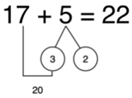
Figure 1: Example of addition that bridges to the decade

In Stage 2, recordings typically focus on groups of 10.
Developing an understanding of multidigit subtraction is generally more challenging than addition (Fuson and Burghardt 2003).
This is due to the lack of understanding of commutativity ie 7 − 2 is not the same as 2 − 7.
There are many ways to effectively develop conceptual understanding of multidigit addition and subtraction (Fuson et al. 1997).
For example, one approach focuses on counting by tens, using the arithmetic rack (rekenrek) or bead strings instead of using base-10 blocks.
Another approach uses Montessori number cards or place value arrow cards.
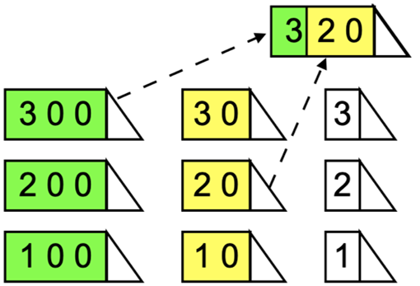
Figure 2: Place value arrow cards

As well as learning how to add and subtract multidigit numbers, it is important that students can make informed choices on the use of computational procedures.
Research indicates that after one year of practising standard algorithms, students often apply the algorithms to questions which are better done using mental computation eg 527 + 399, 601 – 127 (Torbeyns and Verschaffel 2013).
Commonly used subtraction algorithms rely on regrouping. The algorithm can be explained using manipulatives, in which 10 is exchanged for 10 ones and 100 is exchanged for 10 tens, when regrouping is necessary.
However, various studies have shown that the use of concrete materials produces mixed results when it comes to conceptual understanding (Carbonneau et al. 2013).
How well the materials match the student’s concept of place value plays an important role in the effectiveness of materials like base-10 blocks.
If a student hasn’t yet developed a concept of 10 as a composite unit (both 10 ones and 1 ten), using base-10 blocks to represent regrouping will have little meaning.

Three categories of mental computation strategies for multidigit subtraction with regrouping
Strategy flexibility is identifying which strategies may fit with the numerical characteristics and demands of the different problem types.
Although there are different ways of describing mental computation strategies used with multidigit subtraction, the following 3 broad categories capture the common approaches (Hartnett 2007).
- Sequential – left to right, for example:
  - 456 – 298 is 456 − 200 = 256, 256 − 90 = 166, 166 − 8 = 158
- Decomposition – using indirect addition or building up, for example:
  - 456 – 298 is 8 + 8 = 16, 90 + 50 = 140, 300 + 100 = 400; 8 + 50 + 100 = 158
  - 456 – 298 is 458 − 300 = 158 (recognising 298 is 2 less than 300).
The same example has been used to demonstrate the differences between the methods.
This comparison of the different approaches highlights that the third method, using the constant difference to vary the question, can be most effective when the number being subtracted ends in an 8 or 9. Subtraction using indirect addition can be effective when the difference between the 2 numbers is small (eg 713 − 695).

From mental strategies to written algorithms
The ability to add two 2-digit numbers mentally by an efficient method is considered a crucial test of readiness for written computation (Ewbank 1977).
Mental calculation can help students understand how numbers ‘work’ and what their structure is, as well as aiding the understanding and development of written methods of calculation (Heirdsfield and Cooper 2004).

What is an algorithm?
An algorithm is a set of predefined steps used for a class of problems. The best-known algorithms are those associated with the 4 operations in arithmetic.
The most popular subtraction algorithm involving ‘trading units’ is known as the decomposition method* (Brownell and Moser 1949). It relies on partitioning and regrouping. To subtract 39 from 264 using column subtraction, the 264 is thought of as being decomposed into 2 hundreds, 6 tens and 4 ones. Then 1 ten is traded for 10 ones so that 264 is represented as 2 hundreds, 5 tens and 14 ones.
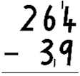

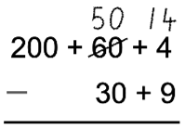
Figure 3: Example of trading units

An advantage of expressing the numbers in an expanded form is that the exchange of units shows the size of the units. In contracted form, the size of the units is masked as it depends upon interpreting the positional value of the units and every trade appears as exchanging a ‘ten’.
Another algorithm for column subtraction is based on the principle that adding the same number to the number being subtracted ie the subtrahend and the minuend, does not alter the difference.¹
This method for column subtraction with trading is known as equal additions and involves adding ten to both numbers.
For example, 10 ones can be added to the minuend and 1 ten to the subtrahend without changing the difference between the 2.
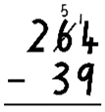

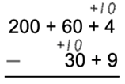
Figure 4: Example of using equal additions of 10

Image long description: Column subtraction of 264 – 39, showing decomposition of 264 into its separate place values and using trading units.
The equal additions method relies on the principle of maintaining a constant difference.
Although there are other subtraction algorithms (eg the complement algorithm) the above 2 have been the most taught (Ellerton and Clements 2012).
Students have an opportunity to deepen their understanding of our base-10 numeration system through using expanded forms of the numbers involved.
* Compensation is a popular method of teaching subtraction because students find it easier to understand than other methods.

Limitations of vertical algorithms
Addition and subtraction problems involving single-digit numbers should not be written vertically. Writing a subtraction of a single-digit number from a 2-digit number in vertical form is not helpful.
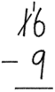
Figure 5: Example of when the vertical algorithm is unhelpful

Encouraging students to only use a vertical algorithm to operate with numbers can inhibit their development of number sense. Students who only use a vertical algorithm, may be less willing to attempt problems in alternative ways and can become afraid to take risks (Narode et al. 1993).

Misconceptions with vertical algorithms
One of the most common misconceptions associated with the subtraction algorithm is known as the smaller-from-larger error (Resnick 2020).
When students focus only on the values of the digits in the subtraction, some ‘simplify’ by reordering the terms to always subtract the smaller value from the larger digit.
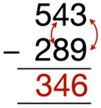
Figure 6: Common misconception with subtraction algorithms

Image long description: Column subtraction of 543 – 289 = 346, with arrows demonstrating the error of switching values when subtracting that requires trading, when students think they 'can't do' 3 - 9 so switch the digits.
Rather than regrouping 40 in 543 as 30 + 10, the response aligns with thinking, ‘I cannot take 9 from 3, so I’ll just take 3 from 9.’
Emphasising the quantity value of the digits and using number expanders can assist in addressing this error. Starting by estimating the answer can also help: Will the answer to the above subtraction be more than 300 or less than 300? Why?
Another common challenge with learning to use the vertical subtraction algorithm is dealing with zeros. Sometimes students believe that 0 means ‘nothing’, so it can be ignored.

A sequence for exchanging in subtraction
1. A 3-digit number minus a 2-digit number (exchanging tens for ones)
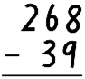

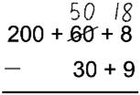

2. A 3-digit number minus a 2-digit number (exchanging hundreds for tens)
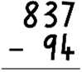

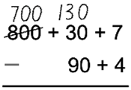

3. A 3-digit number minus a 2-digit number (exchanging tens for ones and hundreds for tens)
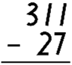

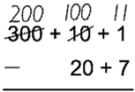

Image long description: Column subtraction of 311 – 27. Numbers are decomposed into place value, with tens exchanged for ones, and hundreds exchanged for tens.
4. A 3-digit number minus a 3-digit number (exchanging tens for ones)
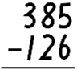

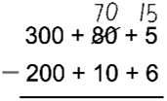

5. A 3-digit number minus a 3-digit number (exchanging hundreds for tens)
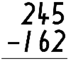

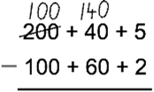

6. A 3-digit number minus a 3-digit number (exchanging tens for ones and hundreds for tens)
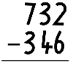

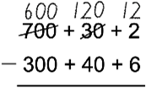

Image long description: Column subtraction of 732 – 346. Numbers are decomposed into place value, with tens exchanged for ones, and hundreds exchanged for tens.
7. A 3-digit number minus a 3-digit number with a zero in the answer
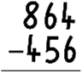

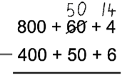

8. A 3-digit number minus a 3-digit number with one zero in the top line
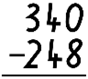

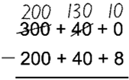

or
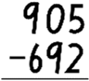

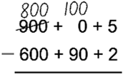

Subtraction from a multiple of one hundred in the top line (such as 300 − 197) has not been included in this sequence as it is often easier to complete these subtractions mentally than with an algorithm.

Mental methods and vertical algorithms
Mental computation still needs to be emphasised even when students can use a formal written method. It is helpful to discuss which questions are better done mentally than using a vertical algorithm. For example, a question such as 2002 − 3 or 1000 − 999 is better done mentally than using a vertical algorithm.
Encourage students to consider the values of the numbers involved in an arithmetical operation before selecting a method to solve the problem (Lucenta and Kelemanik 2022).
Questions such as finding 20 − 19 + 18 − 17 + 16 − 15 + 14 − 13 + 12 − 11, can motivate students to reflect on the numbers involved in a question before calculating.
When developing a formal vertical algorithm, sequence the examples to cover the range of possibilities. The sequence should include questions without trading, questions with trading in one or more places, and questions with one or more zeros in the first number (particularly with subtraction).
For subtraction questions with one or more zeros in the first number, discuss whether the algorithm or mental computation is easier.

Teaching advice documents
- Teaching advice (additional): Stage 2 – Additive relations B (Language and Vocabulary) – Mathematics 3–6

Teaching advice for Multiplicative relations A

Content
- Multiplicative relations A

Teaching advice

What is multiplication?
Developing an appreciation of the operation of multiplication is not easy (Degrande et al. 2018).
Part of the challenge is in describing multiplication. One common description of multiplication is as ‘repeated addition’. This is more a description of what some students might do to solve a multiplication problem than a comprehensive description of multiplication. If multiplication were repeated addition, multiplication would always result in a bigger answer, which is not true.
Multiplication makes use of a structure (one-to-many correspondence) to coordinate groups of groups. Multiplicative relations are those that rely on multiplication.

Modelling multiplication with arrays
Start by forming equal groups (a one-to-many correspondence).
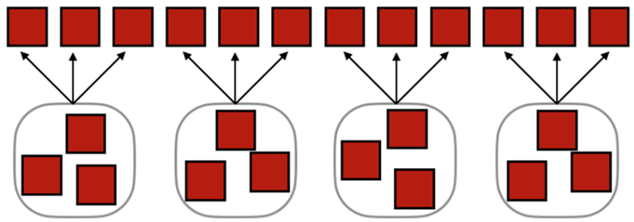
Figure 1: Four groups of three, each group a one-to-many correspondence

When students are familiar with forming groups and can identify both the number of groups and the number in each group, they have the foundations for forming arrays.
Provide opportunities to interpret the row and column structure of the array and how it relates to multiplication.
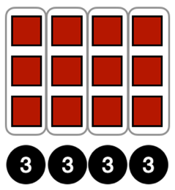
Figure 2: Arrays for 12 linked to the factors 3 and 4

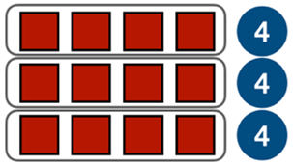

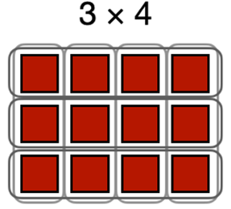

Multiples of 2 and 4, 5 and 10
Students are introduced to counting in multiples as well as using equal groups to represent multiplication in Stage 1 (Forming groups). They also model doubling and halving. When students generate multiplication fact families in Stage 2, they draw on their knowledge of multiples and doubling from Stage 1.
Multiples of 2 are doubled to produce multiples of 4. Multiples of 5 and 10 are supported by the language of our base-10 number system. The number words for these multiples generate a rhythm.
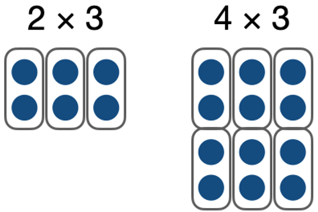
Figure 3: Example of using doubling multiples of 2 to find multiples of 4

Image long description: On the left is the text '2 × 3' above 3 groups of 2 shapes each. On the right is the text '4 × 3' above 6 groups of 2 arranged into 3 even columns.

Relationships and cultural knowledge
Mathematics is practised slightly differently from culture to culture and is also represented differently from country to country (eg in some countries a colon is used as the division symbol). The term ethnomathematics describes ‘the mathematics which is practiced among identifiable cultural groups’ (D'Ambrosio 1985).
Some Aboriginal students may have well-developed conceptual understandings of multiplicative ‘relations’ and ‘relationships’ based on cultural knowledge and practices, such as connections within Country, kinship systems or Community structures.

Multiplication fact families
Multiplication fact families include multiplication facts and their related divisions. For example, having established the fact 2 × 5 = 10, the related facts are 5 × 2 = 10, 10 ÷ 5 = 2 and 10 ÷ 2 = 5.
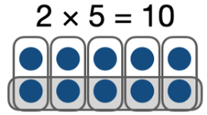
Figure 4: Array used to visually show multiplication facts and the related division

Learning the relationship between the three numbers 2, 5 and 10 can include the use of unknown values.
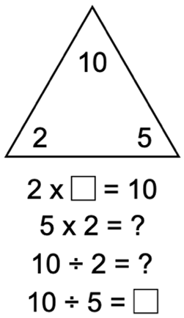
Figure 5: Example of multiplication fact family

Image long description: A triangle with 10, 2 and 5 in the corners. Below is the text '2 × blank = 10', then '5 × 2 = question mark', then '10 ÷ 2 = question mark' and '10 ÷ 5 = blank'.

Mixed practice and multiplication fact families
Multiplication tables have traditionally been learnt in a block by repeated practice. This form of blocked practice has several limitations associated with trying to learn an ordered list of facts (Rohrer 2009).
Multiplication tables are stored as verbal memories (Butterworth et al. 2003).
This can result in students and adults mixing up answers from the tables. For example, the answer to 4 times 8 is sometimes retrieved from memory as 24. This incorrect answer (24) comes from both the 4 times tables (4 × 6) and the 8 times tables (3 × 8).
Rather than producing random answers, most errors are from within the multiplication tables. Choosing the wrong value from the table constitutes between two-thirds and four-fifths of all multiplication recall errors in adults (Domahs et al. 2006).
Learning multiplication facts as related ‘fact families’ produces opportunities for mixed practice. Rather than learning 2 × 5 and 5 × 2 as parts of two separate sets of multiplication tables learnt at separate times, students learn them as related facts. Similarly, learning multiplication fact families enables students to recognise the inverse relationship between multiplication and division.
The more students think about multiplication facts as part of related fact families, the more likely they are to remember them later. Thinking about meaning is much more effective for getting material into memory than thinking about other aspects of the content (Willingham 2008).

Why does the final digit of a number determine if it is odd or even?
One result that follows from our place value system is that any whole number can be written as a multiple of 10 plus a single digit. For example, 153 is 150 plus 3. Since a multiple of 10 is always even because every group of 10 is 2 rows of 5, then whether a number is odd or even can be determined by its final digit.

Language
When students begin to produce multiplication facts it may help to use a language pattern of words that relates back to concrete materials such as arrays. As students become more confident with recalling multiplication facts, they may use less language. For example, '5 columns (or groups) of 3' becomes '5 threes' with the 'columns of' or 'groups of' implied. This then leads to 'one three is 3', '2 threes are 6', '3 threes are nine', and so on.
Words such as 'square' have more than one grammatical use in mathematics, eg draw a square (noun), square 3 (verb), square numbers (adjective) and square metres (adjective).

Vocabulary
Students should be provided with opportunities to develop confidence in using some or all of the following terms to communicate:
- each
- group
- row
- column
- horizontal
- vertical
- array
- multiply
- multiplied by
- multiplication
- multiplication facts
- multiple
- times as many
- double
- halve
- square number
- shared between
- divide
- divided by
- division
- digit
- number chart.

Teaching advice for Multiplicative relations B

Content
- Multiplicative relations B

Teaching advice

Using multiplication facts
Although students may initially use repeated addition to solve multiplication problems, when they have learnt multiplication facts, they should be encouraged to use these facts when multiplying.
Multiplication of tens and hundreds is best taught by encouraging students to think about how to calculate.
2 × 3 = 6
20 × 3 = 60 20 is made up of two 10s, so …
In moving from additive to multiplicative reasoning, multiplication facts are used instead of repeated addition to answer questions like 5 × 60.

Linking multiplication and division
Linking multiplication and division is an important understanding for students by the end of Stage 2. They should come to realise that division 'undoes' multiplication and multiplication 'undoes' division. Students use multiplication facts to divide, eg 35 ÷ 7 is the same as □ ✕ 7 = 35. They should be encouraged to check the answer to a division question by multiplying their answer by the divisor.
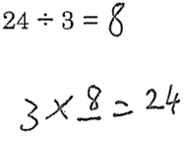
Figure 1: Inverse relationship between multiplication and division

The use of the equals sign key on a calculator can reinforce the mistaken belief that the answer always follows the equals sign, rather than an expression with an equivalent value.

The distributive property
The distributive property is so named because multiplication is distributed over addition. That is, 4 × 7 is the same as 4 × 5 plus 4 × 2 because 7 is 5 + 2. Multiplying by 4 is distributed over the 5 and the 2.
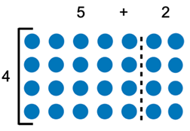
Figure 2: Example of distributive property

Image long description: A group of shapes in 7 columns and 4 rows. The 2 rightmost columns are separated by a dotted line, demonstrating the distributive property of 4 × 7 being the same as 4 × 5 plus 4 × 2.
Multiplying 2-digit numbers and larger relies on the distributive property of multiplication. For example, when we multiply 24 by 7 we can break 24 into 20 and 4 before multiplying each part by 7. When we add the result (140 and 28) we have used the distributive property of multiplication: the product of the sum of two parts is the sum of the products.

Language
As students become more confident with recalling multiplication facts, they may use less language. For example, 'five rows (or groups) of three' becomes 'five threes' with the 'rows of' or 'groups of' implied. This then leads to 'one three is three', 'two threes are six', 'three threes are nine', and so on.
Although multiplication is commutative (ie, 3 × 5 = 5 × 3) division is not. Consequently, distinguishing between the divisor and the dividend in a problem is important. Compare ‘How many times does 4 go into 20?’ with ‘What is 20 divided by 4?’ In each question the divisor is 4 and the dividend is 20 but the order in which they occur is reversed. When modelling decoding division problems, pay particular attention to identifying the divisor and its position following the division symbol: 20 ÷ 4.

Vocabulary
Students should be provided with opportunities to develop confidence in using some or all of the following terms to communicate:
- for each
- times as many
- multiply
- multiplied by
- product
- multiplication
- multiplication facts
- double
- factor
- shared between
- divide
- divided by
- division
- remainder
- equals
- is the same as.

Teaching advice for Partitioned fractions A

Content
- Partitioned fractions A

Teaching advice

Limitations of discrete models of fractions
Using discrete models such as collections of objects can cause difficulty for students. Discrete models can reinforce the idea that fractions are 2 numbers (or 2 counts) rather than a single number.
The count is often the perceived feature of a set or discrete collection model.

Figure 1: This collection of dots asks what fraction of the dots is red?

It is easier to identify the one red dot and the 3 black dots than it is to envision the red dot as one of 4 dots. The unit-whole is difficult to perceive with discrete collections.
Discrete models are generally not helpful in understanding the size of fractions. Two red dots and 6 black dots may represent the same fraction as one red dot and 3 black dots, but they are clearly not the same quantities. Fractions are numbers with specific magnitudes.

Fractions represent a multiplicative relationship
Learning about the size of fractions means learning to interpret and coordinate units that are in a multiplicative relationship (Hackenberg et al. 2016). Dividing a whole into equal parts creates a potential multiplicative relationship between each part and the whole. However, the whole can be interpreted by students as the sum of its parts – that is, as an additive relationship. Counting parts often leads students to interpret fractions as 2 whole numbers.
Students need opportunities to partition linear representations of fractions (eg creating fraction strips) to develop an appreciation of the relationship between parts and the whole arising from the process of division. The adjustments needed to create equal parts emphasise both the equality of the parts and that all the parts must form the whole (Wing and Beal 2004).


Figure 2: Making adjustments to form equal parts by refolding

Two ways of thinking about fractions
Fractions are used in two fundamentally different ways:
- to describe partitions of an object or collection of objects
- to denote numbers (eg the number $$\frac{1}{2}$$ is midway between 0 and 1 on the number line).
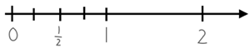
Figure 3: Fractions shown on a number line

In Stage 2, fractions are represented by partitioning lengths. This enables students to measure with partitioned unit fractions. Mapping these lengths to number lines and then aligning the zero point on number lines provides a basis for comparison of fractions as abstract numbers.
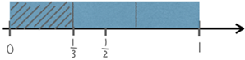
Figure 4: Comparing one-third to one half

Stage 2 focuses on fractions with denominators of 2, 3, 4 and 8, as well as 5 and 10. They are represented as measures by partitioning length. Tenths are introduced to support connections between fraction names and decimal representation.
The representations of partitioned fraction strips are recorded as tape diagrams which can be used to model fractions as division. In turn, the tape diagrams enable the unit length to be mapped to the number line, assisting in the transition from working with fractions as partitioned shapes to fractions as numbers. Tape diagrams, also described as bar models, have been found to provide effective support for students in working with fractions (Spencer and Fielding 2015).

Using fraction strips
Fraction strips or fraction bars are physical models used to introduce tape diagrams. By partitioning fraction strips, students learn to subdivide the whole length into equal parts to represent fractions as measures of length. The number line is then linked to the fraction strips by using it like a ruler to illustrate benchmark fractions of $$\frac{1}{2}$$ or $$\frac{1}{4}$$. The tape diagrams and associated number lines can then act as a tool to support representational transfer.
Representational transfer occurs when tasks make use of a common representation, and the solution procedure is derived from the representation (Novick 1990). That is, the one method of representing a problem is used across different types of problems.
Students may have difficulty creating fraction strips for thirds or fifths because they cannot begin with halving, as is done with quarters or eighths. They may need lots of practice in folding paper strips, drawing shapes and using digital resources such as virtual fraction bars to build mental images that will allow them to visualise and estimate these fractions.

From fraction strips to number lines
Fractions may be interpreted in different ways depending on the context. However, research suggests the number line plays a causal role in students’ fraction magnitude understanding and is more beneficial than the commonly used area model of fractions (Hamdan and Gunderson 2017). Accordingly, fractions and decimal fractions are introduced with fraction strips and bar models leading to number line representations (Gould 2013).

Misconceptions with fractions
Many students view fractions as 2 unrelated whole numbers – three-quarters is the whole number three written over the whole number four. This can lead to students incorrectly applying whole number strategies to fraction problems, such as defining a fraction as the number of equal parts shaded in a circle rather than the relationship between the area of the parts and the whole circle.
Rather than defining a fraction using the notation, numerator over denominator, the fraction concept as a comparison of the fractional part to the whole, should be developed prior to formal work with symbols and algorithms (Cramer and Wyberg 2009). Considering parts of a fraction (the numerator and denominator) in isolation provides no meaning to the value of the fraction as a single number.
Determining how many unit fractions such as quarters ($$\frac{1}{4}$$) or fifths ($$\frac{1}{5}$$) are needed to recreate the whole, highlights the relationship between the numerator and denominator. The use of the words numerator and denominator is not essential in developing a conceptual understanding of fractions and can be left to Stage 3.

What is reversible reasoning?
The ability to reverse a mathematical concept is important at all levels of mathematics. Krutetskii (1976) described reversibility, switching from a direct to a reverse train of thought, as a key mental process in reasoning to solve problems (Krutetskii 1976).
Solutions to reverse tasks require deeper understanding of the underlying concept than solutions to the original tasks (Dreyfus and Eisenberg 1996). Finding the beginning state when given the result, such as producing the whole unit when given $$\frac{3}{4}$$ of it, is more difficult than the original task of finding $$\frac{3}{4}$$ of a unit (Tunc-Pekkan 2015). See also, From the part to the whole: Reversible reasoning in Stage 3.

Teaching advice documents
- Teaching advice (additional): Stage 2 – Partitioned fractions A (Language and Vocabulary) – Mathematics 3–6

Teaching advice for Partitioned fractions B

Content
- Partitioned fractions B

Teaching advice
It is only possible to compare fractional parts when the relation between the wholes is known. When partitioning lengths, one-half of a 6 m length of timber is greater than two-thirds of a 3 m length, because the whole lengths are not equal.
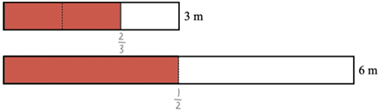
Figure 1: Issue with comparing fractions when wholes are not equal

Iterating fractional lengths
Increasing by a constant fractional value is sometimes colloquially referred to as counting by fractions. However, fractions are not counting numbers. Moreover, counting discrete elements, whether in discrete models or subdivisions of regional models, does not establish the relationship between the parts and whole. Students need to be provided with opportunities to increase fraction lengths beyond the whole.

Representing fractional quantities equal to and greater than the whole
Incrementing by a fractional quantity is intended to focus attention to what happens when a complete unit is formed. When a complete unit is formed, such as 4 quarter litres, it is renamed as a whole unit (1 litre).
When a collection of unit fractions such as 5 quarters exceeds the whole, the reorganisation of the unit parts to form the whole relies upon a clear sense of the whole. Having a unit of measure can make the whole easier to describe.
Making and exceeding the whole is an important precursor to using quantity fractions in Stage 3.

Comparing halves and quarters of different size wholes
In developing a robust understanding of the number line, it is helpful to change the length of the unit representing ‘1’.
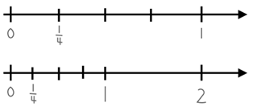
Figure 2: Two number lines showing placement of quarters between whole numbers

Using different length units also provides a rationale for fractions being related to the unit value ‘1’. For example, locate $$\frac{1}{4}$$ on each of the following.
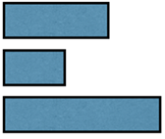
Figure 3: Three bars of different unit lengths

Multiplicative uses of the bar model
Multiplicative relationships can be represented in 2 ways of using the bar model. The first (multiplicative part-whole) shows the intensive part-to-whole fractional relationship.
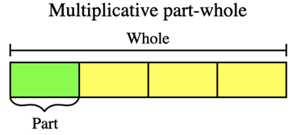

The second (multiplicative comparison) emphasises the ‘times as many’ comparison.
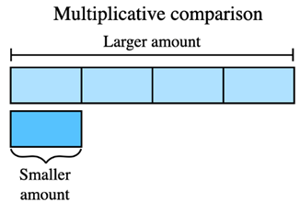

Determining key progress points
The following activity can be used to help determine students understanding of fractional measurement units (Mitchell 2011).
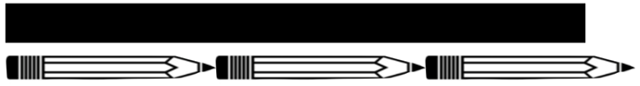

Using the figure above, ask, ‘How long is this black bar in pencils?’ If a whole number is given, prompt eg ‘Is it exactly three?’ ‘How did you work that out?’

Vocabulary
Students should be provided with opportunities to develop confidence in using some or all of the following terms to communicate:
- whole
- fractional part
- equal parts
- half
- quarter
- eighth
- third
- sixth
- fifth
- tenth
- hundredth
- one-sixth
- one-tenth
- whole number
- number line
- is equal to
- equivalent fractions.

Teaching advice for Geometric measure A

Content
- Geometric measure A

Teaching advice

Position
By convention when using grid-reference systems, such as those found on maps, the horizontal component of direction is named first, followed by the vertical component.
A grid reference locates a unique square region on a map rather than a single point. There are 2 parts to a grid reference:
- the first letter or number tells you how far across the map something is
- the second letter or number tells you how far up or down the map something is.
An Aboriginal Languages Map of Australia identifies Language Groups and the Nations to which they belong. It explains the relationship of a particular Aboriginal Nation and may identify significant landmarks or places on Country to which Aboriginal Peoples are connected. Using maps can support students in making connections to their local or known areas.
The grid-reference system is expanded on in Geography. In Mathematics, the grid-reference system is a precursor to introducing coordinates on the Cartesian plane in Stage 3, where the horizontal coordinate is recorded first, followed by the vertical coordinate.

Length
In Stage 2, measurement experiences enable students to develop an understanding of the size of the metre, centimetre and millimetre, to estimate and measure using these units, and to select the appropriate unit and measuring device.

Developing personal benchmarks to estimate
A benchmark is a standard against which something can be compared or measured. Students need to develop personal benchmarks with which to estimate lengths and other measures. Hand width, the unit used to measure the height of a horse, has developed from an informal unit to a standardised measure of approximately 10 cm.
Providing opportunities for students to find things in their environment that are 1 cm, 10 cm and 1 m can help establish benchmarks for convenient units of length. Direct experience of measurement units enables students to establish personal benchmarks and make reasonable estimates.
Students, including those with visual impairments (Jones et al. 2009), tend to be most accurate when estimating measurements ‘in the human scale’ and least accurate with very large or small estimates that cannot be directly experienced (Jones et al. 2009).
When recording measurements, a space should be left between the number and the abbreviated unit, eg 3 cm, not 3cm.

Angles
In Stage 2, students need informal experiences of creating, identifying and describing a range of angles. This will lead to an appreciation of the need for a formal unit to measure angles.
A simple 'angle tester' can be made by placing a pipe-cleaner inside a straw and bending the straw to form two arms. Another angle tester can be made by joining two narrow straight pieces of card with a split-pin to form the rotatable arms of an angle.
Two different coloured intersecting paper plates can be used to show angles as amounts of turn and for comparisons to quarter turns (Host et al. 2014).
Paper folding is a quick and simple means of generating a wide range of angles for comparison and copying.

Misconceptions with angles
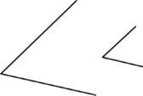
Figure 1: Example of the same angle with different arm lengths

The arms of the angles above are different lengths. However, the angles are the same size, as the amount of turning between the arms is the same. Students may mistakenly judge one angle to be greater in size than another based on the length of the arms of the angles in the diagram.
To assist students in understanding that the length of the arms does not affect the size of the angle, students should be exposed to angles in a variety of orientations and real-world situations. Students should also be exposed to angles where the arm lengths are different.

Language
Teachers can support students to use the language of mathematics by developing understanding that the same word can be used in a range of contexts. Some students may use ‘big’ to signify importance or ‘biggest’ to indicate intensity, such as those who use Aboriginal English. Making connections between concepts and ensuring that students know when the context is mathematical, can support students to select the most appropriate term to use.

Vocabulary
Students should be provided with opportunities to develop confidence in using some or all of the following terms related to Position to communicate:
- position
- location
- map
- plan
- path
- route
- grid
- grid reference
- aerial view
- directions.
Students should be provided with opportunities to develop confidence in using some or all of the following terms related to Length to communicate:
- length
- distance
- metre
- centimetre
- millimetre
- ruler
- measure
- estimate
- handspan.
Students should be provided with opportunities to develop confidence in using some or all of the following terms related to Angles to communicate:
- angle
- amount of turning
- arm
- vertex
- right angle.

Teaching advice for Geometric measure B

Content
- Geometric measure B

Teaching advice

Locating position on a grid map
In Stage 2 the focus of the work on position relates to using grid maps. Students need to have experiences identifying north from a compass in their own environment and then determining the other 3 key directions: east, south and west. This could be done in the playground before introducing students to using these directions on maps to describe the positions of various places.

Length and perimeter
Students need opportunities to interpret length as pertaining to a boundary as well as the straight-line distance between 2 points. Practical activities, like making a kite, provide opportunities for purposeful measuring. When the diagonals of the kite have been formed to make the frame, the length of string around the frame is the perimeter of the kite.

Angles
The focus in Stage 2 angles is on comparison to a right angle. Right angles play an important role in construction. Historically, early tools for measuring right angles include the carpenter’s square which is a guide for establishing right angles. Measuring angles other than right angles requires some consistent unit of measure. Assigning a numerical value in degrees to measure angles of any size, is introduced in Stage 3.

Language
The compass words north, south, east and west can be written with or without capital letters. In English they are often used as nouns or directional adjectives or adverbs (‘going to the south’). The compass words can also be positional, indicating where something is (‘in the east’) rather than where it is going. The prepositions ‘to’ and ‘in’ help distinguish between directional and positional use of the compass words.
'Perimeter' is derived from the Greek words that mean to measure around the outside: peri, meaning 'around', and metron, meaning 'measure'.
The term 'height' usually refers to the distance from the 'base' to the 'top' of an object or shape. The term 'width' usually refers to the shorter side of a rectangle. Another word for width is 'breadth'.
The use of the terms 'sharp' and 'blunt' to describe acute and obtuse angles, respectively, is counterproductive in identifying the nature of angles. It is preferable not to use these terms as they focus attention on the shape of an angle, rather than on the amount of turning between the arms of the angle.

Vocabulary
Students should be provided with opportunities to develop confidence in using the following terms related to Position:
- grid reference
- location
- map
- plan
- compass
- directions
- north
- south
- east
- west.
Students should be provided with opportunities to develop confidence in using the following terms related to Length:
- length
- distance
- metre
- centimetre
- millimetre
- ruler
- tape measure
- trundle wheel
- measure
- estimate
- perimeter
- height
- width.
Students should be provided with opportunities to develop confidence in using the following terms related to Angles:
- angle
- arm
- vertex
- right angle
- acute angle
- obtuse angle
- straight angle
- reflex angle
- angle of revolution.

Teaching advice for Two-dimensional spatial structure A

Content
- Two-dimensional spatial structure A

Teaching advice

2D shapes
It is important for students to have experiences with a variety of shapes in order to develop flexible mental images. Students should continue to work with asymmetric or irregular shapes as well as regular shapes (all sides and all angles equal). Students are not expected to use the terms ‘regular’ and ‘irregular’ themselves. Students also need to be able to recognise shapes presented in different orientations.
The terms ‘regular’ and ‘irregular’ are formally introduced in Stage 3 after students have learnt to measure angles. Although all rectangles have 4 right angles, unlike squares they are not ‘regular’ shapes.

Real-life examples of transforming shapes
When relating two-dimensional shapes content to Aboriginal artworks, artefacts or designs, local examples should be used wherever possible in consultation with local Aboriginal Communities.

Creating tessellations
A tessellation is a special type of tiling. It forms a repeating pattern of geometric shapes that cover the plane without gaps or overlaps. When considering tessellations in 2D shapes, it is helpful to emphasise the shape of the face that tessellates if using pattern blocks. Digital applications can also support a focus on the 2D shapes.
Each polygon used in a tessellation can be broken up into triangles. This process of triangulating tessellations is used in forming a mesh for 3D computer animations.
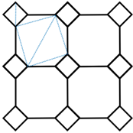
Figure 1: Triangles in a tessellation

Tessellating triangles can engage students in reflecting, rotating and translating triangles. The focus on tessellating with triangles is to help develop an appreciation that any triangle will tessellate. Moreover, students should have an opportunity to recognise that 2 copies of a triangle can form a parallelogram. That is, a triangle is exactly half a parallelogram.
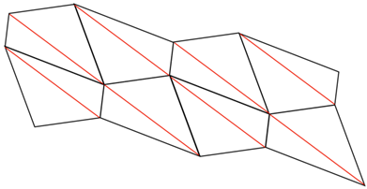
Figure 2: A tessellating quadrilateral showing parallelograms formed from identical triangles

Area
In Stage 2, students appreciate that formal units allow for easier and more accurate communication of measures. Measurement experiences should enable students to develop an understanding of the size of a unit, measure and estimate using the unit, and select the appropriate unit. An important understanding in Stage 2 is that an area of one square metre need not be a square. It could, for example, be a rectangle 2 metres long and half a metre wide.
Dissecting and rearranging the area of a square can help students develop an appreciation of the difference between units. For example, dividing a 2 m by 2 m square with an area of 4 square metres into two rectangles each with an area of 2 square metres can assist in establishing the relationship between edge length and area.
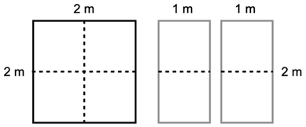
Figure 3: Dissecting area to find relationships

Language
The term 'polygon' (derived from the Greek words meaning 'many angles') refers to closed shapes with 3 or more angles and sides. While the angles are the focus for the general naming system used for shapes, polygons are usually understood in terms of their sides. Students are not expected to use the term 'polygon'. However, some students may explore other polygons and benefit from being introduced to the collective term.
Students could explore the language origins of the names of polygons.
The meaning of terms like ‘trapezium’ have changed over time. Proclus (412 to 485 CE) wrote commentaries on Euclid’s Elements, the classic work on geometry. He described 2 types of trapezia (a term which translates from Greek to mean ‘a table’). The first type with one pair of parallel sides was called a trapezium. The second type with no parallel sides was called a trapezoid. Towards the end of the 18th century the meanings changed in American English. Although British English follows the structure described by Proclus, American English uses the reverse.
The term 'diamond' is often used in everyday contexts when describing quadrilaterals with 4 equal sides. However, 'diamond' is not the correct geometrical term to name such quadrilaterals; the correct term is 'rhombus'.
The standard abbreviations for square metre and square centimetre are introduced in Stage 3. In Stage 2 the units are recorded in words or using informal abbreviations, such as sq m.

Vocabulary
Students should be provided with opportunities to develop confidence in using some or all of the following terms related to 2D shapes to communicate:
- quadrilateral
- parallelogram
- rectangle
- rhombus
- square
- trapezium
- kite
- pentagon
- hexagon
- octagon
- orientation
- features
- side
- parallel
- pair of parallel sides
- opposite
- length
- vertex (vertices)
- angle
- right angle
- symmetry
- line of symmetry
- rigid.
Students should be provided with opportunities to develop confidence in using the following terms related to Area:
- area
- surface
- measure
- grid
- row
- column
- square centimetre
- square metre
- estimate
- vertical
- horizontal.

Teaching advice for Two-dimensional spatial structure B

Content
- Two-dimensional spatial structure B

Teaching advice

2D shapes
Creating two-dimensional shapes by combining and splitting common shapes helps in recognising shapes within other shapes. It also lays the foundation for dissecting and rearranging shapes in a way that preserves their area. Polygons can always be divided into triangles, making triangles the basic building block of polygons.
Students should also attempt to create tessellating designs with a selection of different shapes, including shapes that do not tessellate.

Area
Area relates to the measurement of two-dimensional space in the same way that volume and capacity relate to the measurement of three-dimensional space.
Students should use the row and column structure of a square-centimetre grid overlay to find the area when the shape to be measured is on top of the overlay.
Establishing the relationship that 2 copies of a triangle form a parallelogram assists in understanding how the area of a triangle can be determined. Any triangle can then be thought of as half of a parallelogram.
The standard abbreviations for square metre and square centimetre are introduced in Stage 3. In Stage 2 students have no background for recording square values using ＿².

Determining key progress points

Equal area
Start with 2 identical paper squares. Point to one square.
Ask, ‘Can you show me where the area of this square is?’
If the student is unsure, demonstrate where the area is.
Point to both squares and ask, ‘Are the areas the same?’ followed by ‘How do you know?’
Fold one square in half diagonally and the other in half vertically, in front of the student.
Unfold both squares.
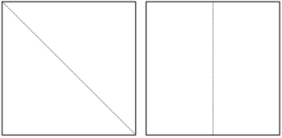

Using the square that was folded diagonally, trace around one triangle with your finger and ask, ‘Can you show me where the area of this triangle is?’
Select the other square and trace around one of the rectangles formed by folding the square in half.
Ask, ‘Can you show me where the area of this rectangle is?’
Cut along the fold lines and place one triangle beside a rectangle from the other square.
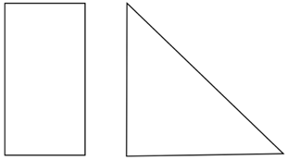

Ask, ‘Do these two shapes have the same area, or is one bigger than the other? Why do you think that?’
Creating two-dimensional shapes by halving equal size squares provides an opportunity to determine if a student recognises different shapes can have the same area. This foundational understanding of area underpins interpreting area models.

Language
Students should be encouraged to use the terms 'translate', 'reflect' and 'rotate' rather than ‘slide’, ‘flip’ and ‘turn’.

Vocabulary
Students should be provided with opportunities to develop confidence in using some or all of the following terms related to 2D shapes to communicate:
- shape
- two-dimensional shape (2D shape)
- triangle
- quadrilateral
- parallelogram
- rectangle
- rhombus
- square
- trapezium
- kite
- pentagon
- hexagon
- octagon
- line of symmetry
- reflect (flip)
- translate (slide)
- rotate (turn)
- tessellate
- clockwise
- anti-clockwise
- half-turn
- quarter-turn
- three-quarter-turn.
Students should be provided with opportunities to develop confidence in using some or all of the following terms related to Area to communicate:
- area
- measure
- grid
- row
- column
- parts of (units)
- square centimetre
- square metre
- estimate.

Teaching advice for Three-dimensional spatial structure A

Content
- Three-dimensional spatial structure A

Teaching advice

3D objects

Nets of three-dimensional objects
Not all three-dimensional objects have nets. For example, a sphere does not have a net. A net is a diagram in which the edges of a polyhedron are shown (Buekenhout and Parker 1998). It is believed that every convex polyhedron has a net (Shephard’s conjecture) (Shephard 1975).
There are 11 distinct nets of a cube and 2 nets of a regular tetrahedron.
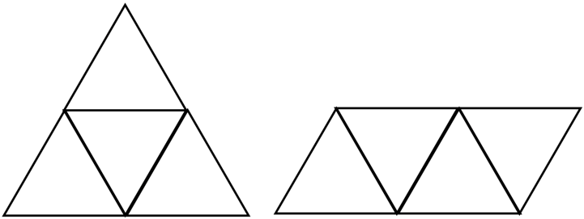
Figure 1: Nets of a tetrahedron

As cylinders and cones are not polyhedrons, their lack of edges means they do not have a net (Friedman 2018).

Volume
Volume relates to the measurement of three-dimensional space, in the same way that area relates to the measurement of two-dimensional space, and length relates to the measurement of one dimension.
The attribute of volume is the amount of space occupied by an object or substance and is usually measured in cubic units, eg cubic centimetres.
Capacity (internal volume) refers to the amount a container can hold and is measured in units such as millilitres (mL), litres (L) and kilolitres (kL). Capacity is only used in relation to containers and generally refers to fluid (liquids and gases) measurement.
The capacity of a closed container will be slightly less than its volume – capacity is based on the inside dimensions, while volume is determined by the outside dimensions of the container. It is not necessary to refer to these definitions with students. It is recommended that the terms ‘capacity’ and ‘internal volume’ be used interchangeably.
In Stage 1, students explore internal volume by filling and packing. From Stage 2, the focus for internal volume shifts to the use of litres. In Stage 2, students appreciate that formal units allow for easier and more accurate communication of measures. Students should be introduced to the litre, millilitre and cubic centimetre. The standard abbreviation for cubic centimetres is introduced in Stage 3. In Stage 2, the units are recorded in words or using less formal abbreviations, such as cc.
Liquids are commonly measured in litres and millilitres. The capacities of containers used to hold liquids are therefore usually measured in litres and millilitres, eg a litre of milk will fill a container that has a capacity of one litre.
Measurement experiences support students in developing an understanding of the size of a unit, to estimate and measure using the unit, and to select the appropriate unit and measuring device.
Estimating is best followed by opportunities to reflect on the initial estimate and build from comparison to a known or familiar unit. For example, when estimating how much liquid a container will hold, provide opportunities for students to adjust their estimates after adding one cup of liquid to the container.
Avoid using images of containers that are not to scale.

Language
In geometry, the term 'face' refers to a flat surface with only straight edges, as in prisms and pyramids, eg a cube has six faces. Curved surfaces, such as those found in cylinders, cones and spheres, are not classified as 'faces'. Similarly, flat surfaces with curved boundaries, such as the circular surfaces of cylinders and cones, are not 'faces'.
The term 'shape' refers to a two-dimensional figure. The term 'object' refers to a three-dimensional figure.
The formal names for particular prisms and pyramids are not introduced in Stage 2. Prisms and pyramids are to be treated as classes for the grouping of all prisms and all pyramids. Names for particular prisms and pyramids are introduced in Stage 3.

Vocabulary
Students should be provided with opportunities to develop confidence in using some or all of the following terms related to 3D objects to communicate:
- object
- two-dimensional shape (2D shape)
- three-dimensional object (3D object)
- cone
- cube
- cylinder
- prism
- pyramid
- sphere
- surface
- flat surface
- curved surface
- curved boundary
- face
- edge
- vertex (vertices)
- net.
Students should be provided with opportunities to develop confidence in using the following terms related to Volume:
- capacity
- container
- litre
- volume
- layers
- cubic centimetre
- measure
- estimate.

Teaching advice for Three-dimensional spatial structure B

Content
- Three-dimensional spatial structure B

Teaching advice

Connecting 3D objects and 2D representations
Some students may not be able to access physical manipulatives for constructing three-dimensional models. For these students, it is appropriate to use digital technologies to assist in creating two-dimensional representations of three-dimensional objects.

Using isometric grids
Isometric grids can be used to draw 3D objects. The horizontal axes on an isometric grid are effectively rotated 30° from the horizontal. The distances between dots on the 30° lines are the same as the distances between dots on the vertical lines. The term isometric comes from the Greek, isos meaning equal and metria meaning measuring.
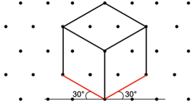
Figure 1: Drawing a cube on isometric dot paper

In Stage 2 students use isometric grids as an aid to represent 3D objects. They do not need to know the properties of isometric grids.
Learning to represent perspective using isometric grids can be quite challenging. Understanding that the 2D shapes that are components of the 3D objects are drawn not as we know them to be, but as they appear to the eye, takes practice. The above isometric drawing of a cube represents the faces which we know to be squares, as rhombuses. Having students take photos of a cube from different angles and finger-tracing around the shapes helps them to understand this phenomenon and gives a rehearsal before drawing.
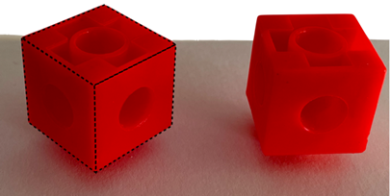
Figure 2: Tracing edges of a cube to identify shapes

Volume
A useful benchmark equivalence for estimating internal volume is to take one cup as holding a quarter of a litre (250 mL).

Language
Capacity refers to the amount a container can hold, whereas volume refers to the amount of space an object or substance (including liquids) occupies. For example, we refer to the capacity of a dam (the amount of water it can hold) and the volume of water in the dam, which is usually less than the capacity of the dam.

Vocabulary
Students should be provided with opportunities to develop confidence in using some or all of the following terms related to 3D objects to communicate:
- object
- two-dimensional shape (2D shape)
- three-dimensional object (3D object)
- cone
- cube
- cylinder
- prism
- pyramid
- top view
- front view
- side view
- isometric grid paper
- isometric drawing
- depth.
Students should be provided with opportunities to develop confidence in using some or all of the following terms related to Volume to communicate:
- capacity
- container
- litre
- millilitre
- volume
- measure
- estimate.

Teaching advice for Non-spatial measure A

Content
- Non-spatial measure A

Teaching advice

Mass
In Stage 2, students learn to appreciate that formal units allow for easier and more accurate communication of measures. Students are introduced to the kilogram and gram. They develop an understanding of the size of these units and use them to measure and estimate.
Using images to compare masses can cause misconceptions in relation to believing bigger items always weigh more. Mass is a concept best taught using physical objects. Where visuals are needed to support the needs of students in accessing the concept of mass, use images of real-life objects on a set of scales so the size and recorded weight are clear.

Time
The duration of a solar year is 365 days, 5 hours, 48 minutes and 45.7 seconds or a little less than 365$$\frac{1}{4}$$ days.
To avoid confusion of the one set of numerals being used for both hours and minutes, some watch faces have 2 separate scales for the hours and minutes.
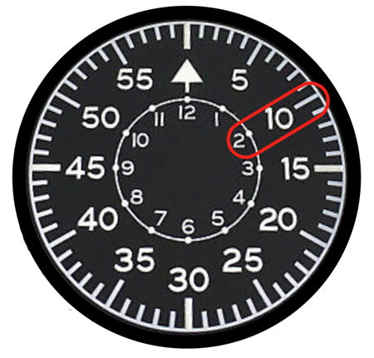
Figure 1: Type B Navigator watch face

The terms ‘hour hand’ and ‘minute hand’, rather than ‘little hand’ and ‘big hand’, should be used to promote understanding of their respective functions.
In Stage 2, the concepts related to time have been separated based on the type of instrument being used to measure the time. Analog clocks are presented in Part A and digital clocks are presented in Part B. This will assist students in developing the language needed for each instrument before using the analog and digital time descriptions interchangeably, as they are very different.
In Stage 1, students focus on the language of analog clocks in telling time to the quarter-hour using the language of ‘past’ and ‘to’.
Students need opportunities to develop the vocabulary to talk about and interpret relative times (eg half past 11) and precise times (eg 2:30). Along with the focus on language, students benefit from learning tangible concepts related to length (such as longer, shorter and equal intervals), prior to learning time on analog clocks (Earnest and Chandler 2021).
When representing 30 minutes as half an hour on a clock face, attention should be paid to the position of the hour hand as well as the minute hand. Students often inaccurately position the hour hand while accurately locating the minute hand (Earnest et al. 2018).

Language
As the terms 'weigh' and 'weight' are common in everyday language, they can be accepted in student language at school should they arise. Weight is a force that changes with gravity, while mass remains constant.
Relative time language includes comparing the minutes to the hour using prepositional or fraction terms eg ten minutes to nine or quarter past eight.
Precise time language includes stating the hour first, and then the minutes eg 4:45 is read as four forty-five pm or am.
Some Aboriginal and/or Torres Strait Islander students may need support in code switching between Eastern Standard Time and Cultural ways of understanding time. Aboriginal and Torres Strait Islander Peoples have a connection and understanding of natural cycles, these cycles are used to indicate time. For example, lunar cycles or tides are used to inform hunting, fishing and agricultural practices.

Vocabulary
Students should be provided with opportunities to develop confidence in using some or all of the following terms related to Mass to communicate:
- mass
- more than
- less than
- about the same as
- pan balance
- (level) balance
- measure
- estimate
- kilogram.
Students should be provided with opportunities to develop confidence in using some or all of the following terms related to Time to communicate:
- time
- clock
- analog
- digital
- hour hand
- minute hand
- second hand
- revolution
- numeral
- hour
- minute
- second
- o'clock
- (minutes) past
- (minutes) to.

Teaching advice for Non-spatial measure B

Content
- Non-spatial measure B

Teaching advice
Midday and midnight do not need to be expressed in am or pm form. '12 noon' or '12 midday' and '12 midnight' should be used, even though 12:00 pm and 12:00 am are sometimes seen in everyday life. The double zero convention for recording digital time on the hour and used in conjunction with the colon, can be quite confusing when learning to tell the time. Expressing and reading digital time for exact hours needs to be explicitly taught.
For further teaching advice related to Non-spatial measure in Stage 2 see Part A.

Language
The term 'scales', as in a set of scales, may be confusing for some students who associate it with other uses of the word 'scales', eg fish scales, scales on a map, or musical scales. Even within mathematics, the word 'scale' has different meanings in different contexts. Scale could mean the enlargement or reduction factor for a drawing, or the scale marked on a measuring device. These other meanings should be discussed with students.
The term 'am' is derived from the Latin ante meridiem, meaning 'before midday', while 'pm' is derived from the Latin post meridiem, meaning 'after midday’.

Vocabulary
Students should be provided with opportunities to develop confidence in using some or all of the following terms related to Mass to communicate:
- mass
- measure
- scale
- kilogram
- gram.
Students should be provided with opportunities to develop confidence in using some or all of the following terms related to Time to communicate:
- calendar
- date
- time
- hour
- minute
- second
- midday
- noon
- midnight.

Teaching advice for Data A

Content
- Data A

Teaching advice
Data can be acquired from the internet, newspapers or magazines, as well as through students' observations, surveys, votes and questionnaires.
The following information on types of data variables provides background knowledge for teaching. Stage 2 students are not expected to classify the type of data they are collecting.

Types of data
The characteristics or attributes that are observed, measured and recorded such as eye colour or height are called variables. In Stage 2, students work with discrete data which is either categorical or numerical.
Categorical data can be separated into distinct groups, eg colour, gender, blood type.
Discrete numerical data describes items or events that can be counted in whole number values, where values in between the whole numbers cannot be found or labelled in the data display. For example, the number of students in each class is an exact whole number amount. The value of a discrete variable is found by counting. In Stage 2, students focus on collecting and graphing discrete data.
Numerical data has variations that are expressed as numbers, eg the heights of students in a class, the number of children in families. Measuring height produces continuous numerical data while number of children in families is an example of discrete numerical data.

Organising and displaying data
Data can be displayed in tables and graphs. Students should be provided with opportunities to consider the use of tables and graphs in real-world contexts. Graphs are frequently used to persuade or influence the reader. A simple table showing counts is often the best way to display categorical data.
Column graphs consist of vertical columns or horizontal bars (Figure 1).
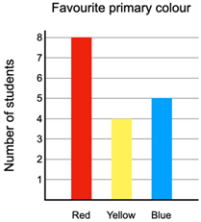

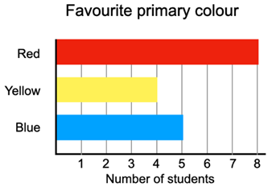
Figure 1: Column graphs

Column graphs are used to represent categorical and more generally, discrete numerical data. When creating column graphs, the columns should not be joined as they represent distinct categorical data.
The term 'bar graph' is reserved for divided bar graphs (Figure 2) and should not be used for a column graph with horizontal bars.
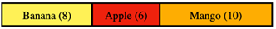
Figure 2: Divided bar graph

Dot plots
Dot plots are an alternative to a column graph when there are only a small number of data values. Each value is recorded as a dot so that the frequencies for each of the values can be counted easily.
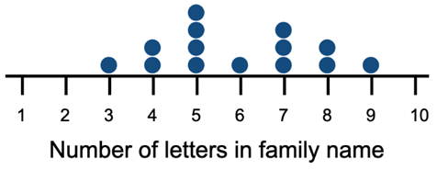
Figure 3: A dot plot showing the lengths of students’ family names

Educational graphing software can provide a virtual environment to explore dot plots, enabling students to interact with and manipulate the data. Dot stickers are also useful resources for making colourful dot plots.
Continuous numerical data that changes over time is introduced in Stage 3, where students are provided with opportunities to collect and interpret continuous data. Line graphs are left to Stage 3 after students have learnt to use scales of many-to-one correspondence. Interpreting continuous data representations can involve estimating between scale values (eg values between two times of the day).

Language

The language of statistical reasoning
Statistical reasoning means understanding and being able to explain statistical processes and being able to interpret statistical results (Garfield 2002). It is the way people reason with statistical ideas and make sense of statistical information. Statistical reasoning may involve connecting one concept to another or combining ideas about data and chance (Watson 2004).
Inference is an important component of statistical reasoning. Learning what can be inferred from the data mirrors learning inference in reading. Inference in reading uses the information in the story to predict, while considering referential and logical relationships. When drawing on the activity of prediction from cues in storybooks, students might be asked to infer things such as a character’s feelings about failing to achieve their goal in a particular story episode, or to predict possible things the character might try to do next.
Encourage students to work through questions that start with what is in the data (‘here’) and move to what can be inferred from the data (‘hidden’). Using the data on length of family names (Figure 3), ‘Most family names had fewer than 7 letters’ is hidden in the data. Asking the question, ‘Do you think this would be the same in a different class?’ encourages students to consider moving beyond the data. Explicitly tying evidence to conclusions is a skill that needs practice and nurturing (Makar 2016).

Vocabulary
Students should be provided with opportunities to develop confidence in using some or all of the following terms to communicate:
- information
- data
- collect
- category
- display
- symbol
- list
- table
- column graph
- dot plot
- vertical columns
- horizontal bars
- equal spacing
- title
- key
- vertical axis
- horizontal axis
- axes
- spreadsheet.

Teaching advice for Data B

Content
- Data B

Teaching advice

Collecting data
Creating effective survey questions often means trialling the questions and redrafting them to make them clearer. It is helpful to have a clear purpose for any survey. Keep the survey short and check that each question relates to the purpose.
The focus area of Data provides opportunities for teachers to incorporate contexts and topics from other key learning areas in mathematics. In Science and Technology students collect data from the tests and experiments they conduct. Mathematics outcomes in Data can be addressed in parallel with those in Science and Technology. Topics being studied in other key learning areas such as HSIE and PDHPE are also good sources of authentic data that can be used in mathematics lessons.

Equal interval scales
Equal interval scales have an equal separation between numbers (units) everywhere on the scale. For example, the separation between one and 2 must be the same as the separation between 29 and 30. The idea of an equal interval scale relates to the use of a scale for measuring length (Bell and Janvier 1981).

Many-to-one scales
A scale of many-to-one uses one unit or interval to represent more than one item or response, such as one centimetre representing 5 items or responses.
A dataset needs to contain a sufficiently large number of data points to warrant a many-to-one scale. A narrow range of values, such as one to 5, doesn’t need to use one. However, recording values that range from one to 83 would typically require a many-to-one scale.

Language
Matching statements on cards to graphs can model survey sentence structures and help students in using a specific set of vocabulary terms.

Vocabulary
Students should be provided with opportunities to develop confidence in using some or all of the following terms to communicate:
- data
- collect
- survey
- recording sheet
- rating scale
- category
- display
- symbol
- tally mark
- table
- column graph
- dot plot
- vertical columns
- horizontal bars
- scale
- equal spacing
- title
- key
- vertical axis
- horizontal axis
- axes
- spreadsheet
- misleading.

Teaching advice for Chance A

Content
- Chance A

Teaching advice
Random generators include coins, dice and spinners. The initial focus in Stage 2 is on random generators producing equally likely outcomes. For example, spinners with unequal areas do not have equally likely outcomes and are not addressed in Stage 2 Chance.
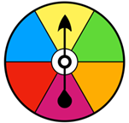

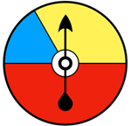
Figure 1: A spinner with equally likely outcomes and one with unequal areas

The process of identifying all possible outcomes, followed by predicting and testing, can help students to form a sense of the nature of chance.
An important emerging understanding is that identifying the possible outcomes can help establish expectations, but the randomness in the experiment means that something different may happen.

Language
The everyday language of chance can be at odds with the precision required in mathematical language. Terms like ‘certain’ or ‘likely’ are used to indicate a possibility in speech, rather than having an exact probability value.
A chance ‘event’ might be selecting a coloured ball without looking, and the ‘outcome’ would be the colour of the ball (Figure 2).

Figure 2: A red, a blue and a yellow ball

In Figure 2, selecting a red, a blue or a yellow ball without looking are ‘equally likely’ outcomes. Note that ‘equally likely’ need not mean a 50–50 chance. For the above example, the balls need to be identical in all aspects except colour.

Vocabulary
Students should be provided with opportunities to develop confidence in using some or all of the following terms to communicate:
- chance
- experiment
- outcome
- random
- trials
- tally
- expected results
- actual results.

Teaching advice for Chance B

Content
- Chance B

Teaching advice

Expectation and variation
Randomness can lead to unexpected outcomes. The ‘law of averages’ is a term sometimes used to describe the common mistaken belief that an outcome must occur as many times as its numerical probability suggests. This belief suggests that what has happened in the past will be balanced by what occurs next. An example of the ‘law of averages’ is the belief that if a coin has come down heads 6 times in a row, it is likely to be tails on the next toss.
Theoretically, when a fair coin is tossed, there is an equal chance of obtaining a head or a tail. If the coin is tossed and 5 heads in a row are obtained, there is still an equal chance of a head or a tail on the next toss, since each toss is an independent event. It is not possible that the coin toss can be influenced by what has just happened, as it doesn’t know.
Students need many opportunities to compare their expectations (what might happen) with actual outcomes (what does happen) to appreciate the variation that is experienced with random generators.

Comparing likelihood
Comparing the likelihood of events depends upon a sense of proportion. Realising there is a greater likelihood of obtaining a ‘tail’ when tossing a coin than rolling a ‘6’ using standard dice, is based on intuitively comparing ratios. Comparing the likelihood of events should focus only on ratios that are very familiar to students.

Language
As described in Part A, everyday use of chance language is imprecise. It is not intended that precise measures of chance are assigned to commonly used terms such as ‘likely’ or ‘unlikely’. It is best to avoid activities of assigning precise positions on a number line to imprecise chance terms, such as ‘possible’.

Vocabulary
Students should be provided with opportunities to develop confidence in using some or all of the following terms to communicate:
- chance
- event
- possible
- impossible
- likely
- unlikely
- less likely
- more likely
- most likely
- least likely
- equally likely
- more often
- less frequent
- experiment
- outcome.

Glossary

Mathematics K–10 (2022) Terms
absolute error
In a measurement, half of the smallest unit of the measuring device. The smallest unit is called the precision of the device.
access content points
Content for students with significant intellectual disability who are working towards the Early Stage 1 outcomes. Teachers can use the access content points on their own, or in combination with the content for each outcome.
accuracy
The extent to which measurements are considered to be close to the true value.
acute angle
An angle smaller than a right angle, between 0° and 90°.
Extended in Mathematics Advanced and Extension 1: In circular measure, an angle lying in the interval $$\left[0,\frac{π}{2}\right].$$
adjacent
Has different meanings for different mathematical contexts. For example, adjacent vertices in a network are joined by an edge and adjacent faces in a solid have a common edge. In trigonometry, the adjacent side of a right-angled triangle is the side next to the angle to which the trigonometric ratio is referring.
adjacent angles
Angles that share a vertex and an arm. They do not overlap.
Extended in 7–10: Two angles at a point are called adjacent if they share a common ray and a common vertex and lie on opposite sides of the common ray.
algebraic expression
A mathematical statement formed by combining numbers and algebraic symbols using arithmetic operations, e.g. $$a^{2}+3ab-2b^{2}$$.
algebraic fraction
A fraction in which the numerator and/or the denominator are algebraic expressions.
algebraic term
Forms a 'separable' part of some other algebraic expression. For example, $$x^{2}$$ and $${5x}^{-1}$$ are terms in the inequality $$x^{2}≤{5x}^{-1}$$, and 2, $$-3x$$, $${5x}^{2}$$ are terms of the polynomial $$2-3x+{5x}^{2}$$.
alternate angle
In each diagram below, the 2 marked angles are called alternate angles (since they are on alternate sides of the transversal).
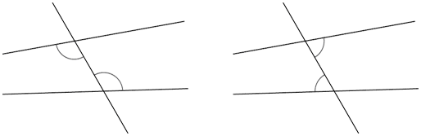
If the lines $$AB$$ and $$CD$$ are parallel, then each pair of alternate angles is equal.
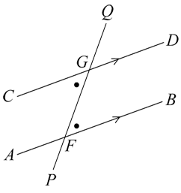
angle
Formed by 2 straight lines meeting at a common endpoint, called the vertex. An angle can describe the amount of turn between its 2 arms (lines).
angle of depression
The angle between horizontal and the line of sight from an observer to an object that is lower than the observer.
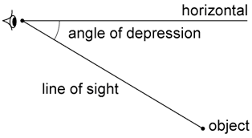
angle of elevation
The angle between horizontal and the line of sight from an observer to an object that is higher than the observer.
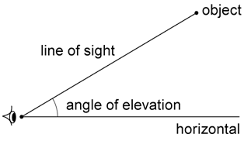
angle of inclination
The angle a straight line makes with the positive $$x$$-axis.
approximate
An estimate of a number or an amount to a particular accuracy. For example, $$\frac{22}{7}$$ and 3.1416 are approximate values, or approximations, for the number $$π$$.
arc
A part of a circle’s circumference.
Extended in Mathematics Extension 1: A part of a curve.
array
One of several different arrangements that can be used to model multiplicative situations. It is made by arranging a set of objects, such as counters, into columns and rows. Each column must contain the same number of objects as the other columns, and each row must contain the same number of objects as the other rows.
associative law
When more than 2 numbers are added or multiplied, the result is unchanged regardless of how they are grouped or associated. For example, addition of numbers is associative, and the corresponding associative law is: $$\left(a+b\right)+c=a+\left(b+c\right)$$ for all numbers $$a$$, $$b$$ and $$c$$.
Multiplication is also associative: $$\left(ab\right)c=a\left(bc\right)$$ for all numbers $$a$$, $$b$$ and $$c$$.
asymptote
A straight line (or another curve) that a curve approaches as $$x$$ tends to $$±∞$$, or to some particular value.
For example, the curve $$y=2^{x}$$ has an asymptote $$y=0$$ as $$x$$ tends to $$-∞$$, and the curve $$y=\frac{1}{x}$$ has asymptotes $$x=0$$ and $$y=0$$ as $$x$$ tends to $$0$$ and $$±∞$$ respectively.
attribute
A quality, feature or characteristic of an object or shape.
average
A number expressing a central or typical value in a set of data. While it usually refers to the arithmetic mean, that is, the sum of a set of numbers divided by the number of numbers in the set, it may also refer to other measures of centre.
base
Has different meanings for different mathematical contexts. A base is a number that is raised to a power and the base of a solid is the face the object rests on.
bearing
A direction from one point on the Earth’s surface to another. Two types of bearings may be used: compass bearing and true bearing.
See compass bearing and true bearing
bias
A systematic favouring of certain outcomes more than others, due to unfair influence (knowingly or otherwise).
binomial expression
An algebraic expression with 2 terms. For example, $$x+y$$ is a binomial expression in the 2 terms $$x$$ and $$y$$.
bivariate data
Data relating to measurement of 2 variables. It can be categorical data, numerical data or a combination of both.
box plot
A synonym for a box-and-whisker plot. A graphical display of a 5-number summary of data. The ‘box’ covers the middle 50% of scores. The ‘whiskers’ extend to the maximum and minimum values in the dataset.
In a box plot, the 'box' covers the interquartile range (IQR). A vertical line in the box is used to indicate the location of the median.
The box plot below has been constructed from the 5-number summary of the resting pulse rates of 17 students.
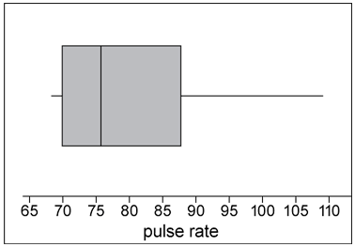
capacity (internal volume)
Generally refers to the amount a container can hold.
A term used to describe how much a container will hold. It is often used in relation to the volume of fluids. Units of capacity (volume of fluids or gases) include litres and millilitres.
See internal volume (capacity)
Cartesian coordinate system
A system that specifies the position of each point in a plane, formed by the intersection of 2 perpendicular number lines called axes. Each point is represented by an ordered pair $$(x,y)$$of real numbers called the coordinates of the point. The point where the axes meet is called the origin and has coordinates $$(0,0)$$.
categorical variable
A variable whose values belong to exactly one of a number of categories. A categorical variable describes a quality or characteristic of something. Sometimes called a discrete variable. There are 2 types of categorical variables: nominal and ordinal. For example, your home state or blood type are categorical variables.
causal
Two variables with a relationship which indicates that one event is the result of the occurrence of the other event.
chance
A possibility of something happening.
chord
A line segment (interval) joining 2 points on a circle.
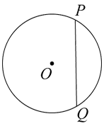
circle
All points equal to a given distance from a fixed point, the centre. When used to describe a shape, a circle includes all points inside the boundary.
circuit (networks)
A path that begins and ends on the same vertex. Vertices can be repeated.
circumference
The boundary of a circle. The length of the circumference $$C$$ is given by $$C=πd$$, where $$d$$ is the diameter. Alternatively, it is given by $$C=2πr$$, where $$r$$ is the radius.
closed shape
A shape enclosed by all its sides with no gaps.
co-interior angles
A pair of angles that lie between a pair of parallel lines cut by a transversal and have a sum of 180 degrees or 2 right angles.
In each diagram the 2 marked angles are called co-interior angles.
If the 2 lines are parallel, then co-interior angles add to give 180° and so are supplementary.
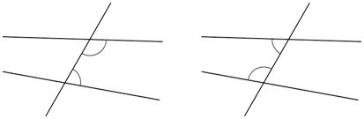
Co-interior angles formed by parallel lines are supplementary. In the diagram below the angles ∠CGF and ∠AFG are supplementary. If the lines $$AB$$ and $$CD$$ are parallel then $$α+β=180$$:
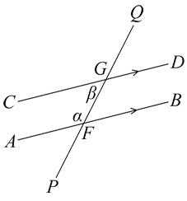
Conversely, if a pair of angles are supplementary, then the lines are parallel.
coefficient
A numerical quantity that multiplies a variable in an algebraic expression, e.g. 5 is the coefficient of $$5x$$. Variables with no specified coefficient have a coefficient of 1.
collinear
Describes points that lie on the same straight line.
combinations
The various ways a group of items can be arranged without regard to order.
commission
The sum or percentage paid for services, e.g. to an agent or salesperson.
common factor
A factor of each element of a set of numbers or an algebraic expression. Also known as common divisor. For example, 6 is a common factor of 24, 54 and 66, and $$x+1$$ is a common factor of $$x^{2}-1$$ and $$x^{2}+5x+4$$.
commutativity (commutative property)
Commutativity (commutative property) of addition or multiplication means that 2 numbers can be added or multiplied in any order and the solution will be the same.
Commutative law, commutativity and turn-around facts are interchangeable terms.
compass bearing
Angles either side of north or south. For example, a compass bearing of N50°E is found by facing north and moving through an angle of 50° to the east.
complementary angles
Two adjacent angles that form a right angle, i.e. the sum of the angles measured in degrees is 90°.
complementary events
Two mutually exclusive outcomes in a probability experiment, such that $$P(A)+P(B)=1$$ where $$P(A)$$ is the probability of event $$A$$ and $$P(B)$$ the probability of event $$B$$.
Extended in Mathematics Standard and Advanced: Two mutually exclusive events that make up the sample space.
composite number
A non-zero natural number that has a factor other than 1 and itself. For example, all even numbers besides 2 are composite numbers. Some odd numbers are composite (e.g. 21) but not all are composite (e.g. 11).
composite shape
A shape that is formed by combining other plane shapes. Composite shapes are often described as 'complex' when they are made up of many and different shapes.
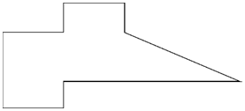
compound interest
The interest earned by investing a sum of money (the principal) when each successive interest payment is added to the principal for calculating the next interest payment.
concavity
Indicates whether the curve ‘opens’ up (concave up) or ‘opens’ down (concave down). For example, the parabola $$y=x^{2}$$ is concave up and the parabola $$y=-x^{2}$$ is concave down.
conditional probability
Consideration of whether the knowledge of the occurrence of one event, A, affects the probability of occurrence of another event, B.
Extended in Mathematics Advanced: The probability of an event $$A$$ occurring, given that another event $$B$$ has occurred, notated as $$P\left(A | B\right)$$ (read as ‘probability of $$A$$ given $$B$$’).
congruent
An exact match between every part of one figure with the corresponding part of another figure, i.e. congruent figures can be exactly superimposed on each other.
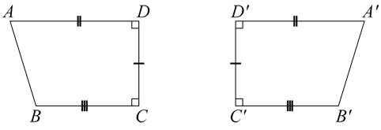
connected
In the Cartesian plane, 2 points are connected if there is a line or curve that joins them. In a network, a set of points is connected if every point can be reached from another point. A set of points that is not connected is called disconnected.
Examples of a connected network and a disconnected network respectively are shown below:
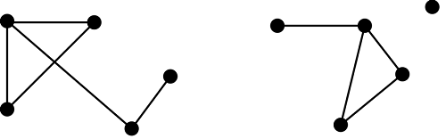
conserved
Not created or destroyed.
constant
A fixed numerical value. For example, in the algebraic expression $$x+11$$, the number 11 is a constant.
constant difference
Constant difference refers to a common difference between pairs of numbers. For example, the difference between 3 and 7 is 4, and another pair of numbers that has a difference of 4 is 2 and 6.
container
Objects such as bottles, jars and tubs.
continuous variable
A numerical variable that can take any value that lies within an interval. The values taken are subject to the accuracy of the measuring instrument used to obtain these values. For example, height, reaction time to a stimulus and systolic blood pressure.
converse
If one relationship is true, then the opposite is also true.
The converse of a statement ‘If $$P$$ then $$Q$$' is 'If $$Q$$ then $$P$$'. For example, the converse of Pythagoras’ theorem is that if the sum of the squares of 2 sides of a triangle is equal to the square of the third side, then the triangle is right-angled.
Extended in Mathematics Extension 2: The converse of $$P→Q$$ is $$Q→P$$ or $$P←Q$$.
coordinates
A set of values that define the position of a point or an object in a space. The coordinate system being used will govern the nature of the coordinates.
corresponding angles
Angles that lie in the same relative position at the points of intersection where a pair of lines is cut by a transversal.
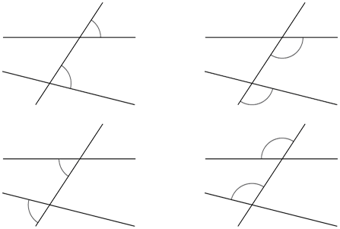
If the lines are parallel, then each pair of corresponding angles is equal.
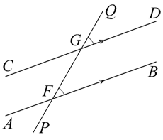
Conversely, if a pair of corresponding angles is equal, then the lines are parallel.
cosine ratio
The ratio of the length of the base, $$b$$, of a right-angled triangle to the length of its hypotenuse, $$h$$, for a given base angle theta, $$θ$$. In any right-angled triangle, $$\cos{θ=\frac{adjacent}{hypotenuse}}$$, where $$0<θ<90°$$.
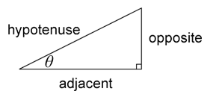
cross-section
The intersection of a solid with a plane. May differ for a given solid depending on the orientation of the slicing plane. For example, the cross-section of a sphere will be a circle (of different radius depending on the slicing plane), while the cross-section of a cube could be a square or other polygon (e.g. triangle, hexagon) depending on the orientation of the slicing plane.
cube
An object with 6 equal square faces and 12 edges.
cube root
The inverse or opposite of cubing a number. For example, the cube root of 8 is 2 because $$2×2×2=8$$. In symbols it is written $$\sqrt[3]{8}=2$$.
cubic
Having the form of a cube or being of the third power or degree.
curve
A one-dimensional figure that is not straight.
curved surface
Surface of an object that is not flat, e.g. a cylinder has one curved surface.
cycle (networks)
A trail that finishes on the vertex it begins on. No vertex is repeated.
cyclic quadrilateral
A quadrilateral with every vertex (corner point) on a circle’s circumference.
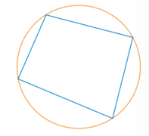
cylinder
An object that has parallel circular discs of equal radius at the ends that are joined by a curved surface.
data
Facts or units of information collected together.
dataset
A collection of numbers or values relating to a particular subject. Datasets are normally presented in tables or represented by graphs. For example, the test scores of each student in a particular class.
decimal
Used to describe aspects of the base-10 number system. The decimal point (. or ,) separates the whole number part of a number from its decimal part.
degree (networks)
The degree of a vertex is the number of edge ends at that vertex.
degrees (geometry)
A unit for measuring an angle. Angles are measured as a proportion of a full turn, which is equivalent to 360 degrees, so that one degree, written as $$1°$$ is equal to $$\frac{1}{360}$$ of a full turn.
denominator
Comes from Latin, meaning ‘that which gives a name’ [de- “completely”; nomen “name”]. The denominator of a fraction identifies the name of the fractional parts (e.g. thirds, quarters or fifths).
Extended in 7–10: In the fraction $$\frac{a}{b}$$, b is the denominator.
dependent events
An event that relies on another event to happen first. One event influences the probability of another event.
dependent variable
The variable used to represent the output values of a function. A dependent variable is generally represented on the vertical axis of a graph.
depreciation
A decrease in value due to wear and tear, decay, decline in price etc.
diameter
A chord passing through the centre of a circle. The word is also used for the length of the diameter.
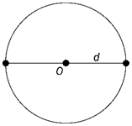
difference
The difference of 2 numbers is the result of subtracting one from the other. You can use subtraction or addition to find the difference between 2 numbers.
For example, to find the difference between 15 and 21, you can:
- add 5 up from 15 to get to 20, then add one more to get to 21, so the difference is 6
- start with 21 and count back to find the difference of 6.
direct variation
A proportional relationship where one quantity directly varies with respect to a change in another quantity. This implies that if there is an increase (or decrease) in one quantity then the other quantity will experience a proportionate increase (or decrease).
discrete variable
Individual and countable items that can be listed.
Extended in Mathematics Advanced: Also known as a discrete random variable.
distribution
The spread of data which can be shown graphically or in a table.
distributivity (Distributive law)
Multiplication of numbers is distributive over addition because the product of one number with the sum of 2 others equals the sum of the products of the first number with each of the others. For example, the product of 3 with $$\left(4+5\right)$$ gives the same result as the sum of $$3×4$$ and $$3×5$$:
$$3×\left(4+5\right)=3×9=27$$ and $$3×4+3×5=12+15=27$$
The distributive law is expressed algebraically as follows:
$$a\left(b+c\right)=ab+ac$$, for all numbers $$a$$, $$b$$ and $$c$$.
dividend
The number that is divided or distributed in a division problem. For example, in $$12÷3=4$$, 12 is the dividend.
domain
The set of allowable values of $$x$$ in a function or relation.
Extended in Mathematics Advanced, Extension 1 and Extension 2: For a function or relation, it is the set of real numbers on which the function or relation is defined.
doubling and halving
Doubling and halving is a strategy that can make solving multiplication problems easier, e.g. solving 4 x 12 is the same as solving 2 x 24.
Doubling and halving is also a strategy used to find factors of a number. For example, to find the factors of 24, start with 1 x 24 then double and halve, 2 x 12, 4 x 6, 8 x 3.
edge
The line segment formed by the intersection of two faces of a polyhedron, e.g. a cube has 6 faces and 12 edges.
edge (networks)
A line that joins vertices to each other in a network diagram.
element(s)
A member of a set. For example, $$3$$ is a member of the set of natural numbers $$N=\{0,1,2,3,4,...\}$$. This relation can be written more concisely as $$3∈N$$ ('$$3$$ is an element of the set $$N$$').
enlargement
A type of transformation that increases or decreases the size of an image without changing its shape, depending on the size of the enlargement factor.
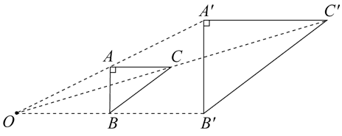
equal-arm balance
A balance where the distance from the support point (middle) to the arms at each end is equal.
equally likely outcomes
An event for which all outcomes have the same probability of occurring. For example, in tossing a fair coin, the outcome ‘head’ and the outcome ‘tail’ are equally likely. In this situation, 𝑃(head)=𝑃(tail)=0.5.
equals sign
In mathematics, the equals sign is used to indicate equivalence, e.g. 5 + 1 = 2 + 4 and to show that two or more amounts have the same value.
See equivalent
equation
An expression showing the equality of 2 quantities, using the = sign between them. A mathematical formula asking for a solution so that the 2 expressions in that variable are equal, e.g. $$x^{2}-1=x$$.
equiangular
When the angles of one polygon are equal to the corresponding angles of another polygon.
equivalent
Two things are equivalent if they have the same value.
See equal, equals sign.
Extended in Mathematics Advanced, Extension 1 and Extension 2: Two things are equivalent if they have the same value, function or meaning. For example, $$y=a^{x}$$ and $$x=\log_{a}{y}$$ are equivalent. Statements $$P$$ and $$Q$$ are equivalent if $$P$$ implies $$Q$$ and $$Q$$ implies $$P$$.
equivalent fractions
Fractions that are different representations of the same value, e.g. $$\frac{1}{2}=\frac{2}{4}=\frac{4}{8}$$.
Two fractions $$\frac{a}{b}$$ and $$\frac{c}{d}$$ are equivalent if they are equal, that is, $$ad=bc$$.
event
Situations that occur in the everyday context, e.g. having lunch. In the context of probability, the set of possible outcomes.
Extended in 7–10: A subset of the sample space for a random experiment. For example, the set of possible outcomes from tossing 2 coins is $$\{HH,HT,TH,TT\}$$, where H represents a 'head' and T is a 'tail'. For example, if $$A$$ is the event 'at least one head is obtained', then $$A=\{HH,HT,TH\}$$.
exponential relationship
A relationship in which the independent variable occurs as an exponent (or power/index) with a positive base. For example, $$y=2^{x}$$ is an exponential relationship where $$x$$ is the independent variable. The graph of an exponential relationship is an exponential curve.
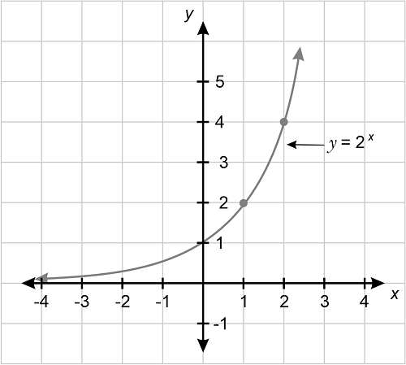
expression
Two or more numbers or variables connected by operations. For example, $$17-9$$, $$8×\left(2+3\right)$$, $$2a+3b$$ are all expressions. Expressions do not include an equals sign.
Extended in Mathematics Advanced, Extension 1 and Extension 2: The result of combining numbers, variables and operations in a meaningful way. For example, $$\frac{x^{3}-1}{\sin{y}}$$ is an expression, but $$(x³-)∫/\sin{y}$$ is not a validly formed expression.
extrapolate/extrapolation
Occurs when the fitted model, such as a line of best fit, is used to make predictions using values that are outside the range of the original data upon which the fitted model was based.
face
A flat surface of a 3-dimensional geometric object (polyhedron) with only straight edges.
face (networks)
A bounded region in a network.
factor
A number that divides another number without a remainder. For example, 1, 2, 3 and 6 are factors of 6 but 4 and 5 are not.
Extended in 7–10: Numbers or algebraic expressions are factors (or divisors) of another number if they multiply to give that number. For example, 3 and 4 are factors of 12 as $$3×4=12$$. This can be written algebraically as $$x$$ and $$y$$ are factors of $$m$$, if $$m=xy$$.
factor theorem
If $$p\left(x\right)$$ is a polynomial and $$p\left(a\right)=0$$ for some number $$a$$, then $$p\left(x\right)$$ is divisible by $$x-a$$. The factor theorem can be used to obtain factors of a polynomial.
factorise
To express a number or algebraic expression as a product. For example, 15 is factorised when expressed as a product: $$15=3×5$$ and $$x^{2}-3x+2$$ is factorised when written as a product: $$x^{2}-3x+2=\left(x+1\right)\left(x-2\right)$$.
five (5)-number summary
A method for summarising a dataset using 5 statistics: the minimum value, the lower quartile, the median, the upper quartile and the maximum value.
fraction
The result of a division. For example, 2 divided by 4 produces quarters. Fractions also represent:
- a relationship or ratio
- parts when a whole is partitioned into equal parts
- numbers between whole numbers
- units of measure.
frequency
The number of times that a particular value occurs in a dataset. For grouped data, it is the number of observations that lie in that group or class interval. For example, when rolling a dice 20 times, ‘the frequency of a 6’ means how many times the number 6 comes up.
frequency distribution
A visual display that organises and presents frequency counts of scores so that the information can be interpreted more easily.
Frequency distributions can be displayed in tabular or graphical form.
function
A function $$f$$ assigns to each element of one set $$S$$ precisely one element of a second set $$T$$.
The functions most commonly encountered in elementary mathematics are real functions of real variables. For such functions, the domain are sets of real numbers.
Functions are usually defined by a formula for $$f\left(x\right)$$ in terms of $$x$$. For example, the formula $$f\left(x\right)=x^{2}$$, defines the ‘squaring function’ that maps each real number $$x$$ to its square $$x^{2}$$.
future value
The total value of an investment or annuity at the end of a specified term, including all contributions and interest earned.
gradient
The slope of a line. It is calculated as the gradient of a line segment it contains. If $$A(x_{1},y_{1})$$ and $$B(x_{2},y_{2})$$ are 2 distinct points on a line, the gradient of the line (or line segment $$AB$$) is given by $$m=\frac{y_{2} - y_{1}}{x_{2} - x_{1}}$$.
graph
A visual representation of statistical data or of a relationship between variables. Ordered pairs of values ($$x,y$$) that represent the function or relation are plotted to form a graph. Graphs of statistical data include dot plots, box plots, column graphs, divided bar graphs and histograms.
Extended in Mathematics Advanced, Extension 1, Extension 2: For a function $$f$$, its graph consists of all ordered pairs $$(x,f(x))$$ for $$x$$ in the domain of $$f$$.
Gregorian calendar
The Gregorian calendar is the most widely used solar dating calendar. It was introduced in 1582 as a modification of the Julian calendar.
grouping division
Grouping (quotitive) division requires finding how many groups are formed, e.g. if I have 12 marbles and each child gets 4, how many children will get marbles?
When grouping, the quotient represents the number of groups within the shared quantity.
hectare
A common unit of land measure in the metric system equal to 10 000 square metres (approximately 2.47 acres).
hefting
Testing the weight of an object by lifting and/or balancing it.
hemisphere
Half of a sphere.
highest common factor (HCF)
The common divisor of a given set of natural numbers that is greater than each of the other common divisors. For example, 1, 2, 3 and 6 are common factors of 24, 54, and 66, and 6 is the highest common factor.
hyperbola
The graph of $$y=\frac{1}{x}$$ produces what is called a rectangular hyperbola. The $$x$$- and $$y$$- axes are asymptotes.
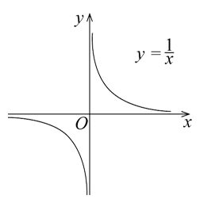
hypotenuse
The longest side in a right-angled triangle that is opposite the right angle.
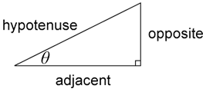
hypothesis
A supposition or proposed explanation made on the basis of limited evidence as a starting point for further investigation.
independent events
Two events are independent if knowing the outcome of one event tells us nothing about the outcome of the other event.
independent variable
A variable used to represent values in the domain (input values) of a function. Generally represented on the horizontal axis of a graph.
index
Also called ‘exponent’. The power to which a number or algebraic expression is to be raised. The index or exponent is written as a superscript. Positive integral exponents indicate the number of times a term is to be multiplied by itself.
indices
The plural of the term index.
inequality
A statement that one number or algebraic expression is less than (or greater than) another. There are 4 types of inequalities:
- $$a$$ is less than $$b$$ is written $$a<b$$
- $$a$$ is greater than $$b$$ is written $$a>b$$
- $$a$$ is less than or equal to $$b$$ is written $$a≤b$$
- $$a$$ is greater than or equal to $$b$$ is written $$a≥b$$.
Extended in Advanced, Extension 1, Extension 2: An order relation between one number or algebraic expression and another.
inference
A conclusion reached on the basis of evidence and reasoning.
infographic
A chart, diagram or illustration (as in a book or magazine or on a website) that uses graphic elements to present information in a visually striking way.
integer
A whole number, positive, negative or zero, e.g. −3, −2, −1, 0, 1, 2 …
Extended in Advanced, Extension 1, Extension 2: The set of integers is usually denoted by ℤ.
intercept
The point at which a curve or function crosses an axis or other curve in a plane. The point at which a curve crosses the $$x$$-axis $$(y=0)$$ is called the $$x$$-intercept and the point at which a curve crosses the $$y$$-axis $$(x=0)$$ is called the $$y$$-intercept.
Extended in Advanced and Extension 1: The $$x$$- and $$y$$-intercepts are sometimes taken to mean the signed distance from the point at which the curve crosses the axis to the origin, e.g. for the line $$y=mx+c$$, the $$y$$-intercept is $$c$$.
interior angle
When referring to polygons, the inner angles formed by 2 adjacent sides.
When referring to a transversal cutting through a pair of straight lines, the 4 angles formed are called interior angles.
internal volume (capacity)
A measure of how much a container can hold.
interpolate/interpolation
Making predictions between known data values. For example, working between 2 known points on a graph to predict a value in between these points.
interquartile range (IQR)
A measure of the spread within a numerical dataset. It is equal to the upper quartile $$\left(Q_{3}\right)$$ minus the lower quartile $$\left(Q_{1}\right)$$; that is, $$IQR=Q_{3}-Q_{1}$$.
The IQR is the width of an interval that contains the middle 50% (approximately) of the data values.
interval
A continuous subset of the real number line. For example, ‘the set of all real numbers greater than or equal to 10’.
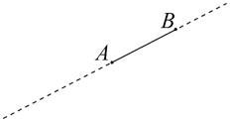
inverse operation
The operation that reverses the effect of another operation.
Examples:
- Addition and subtraction are inverse operations. When you add 3 to 7 you get 10. If you then subtract 3, you get back to 7.
- Multiplication and division are inverse operations. When you multiply 6 by 2 you get 12. If you then divide by 2 you get back to 6.
inverse variation
When one variable increases as the other variable decreases. For example, if $$y$$ is said to be ‘inversely proportional’ to $$x$$, the equation is of the form $$y=\frac{k}{x}$$, where $$k$$ is a constant of variation (or proportion). Also known as inverse proportion.
irrational number
A number that cannot be expressed as a fraction in the form $$\frac{m}{n}$$, where $$m$$ and $$n$$ are integers and $$n$$ is non-zero. The decimal form of irrational numbers does not terminate and is non-recurring.
jump strategy
A mental calculation method that involves jumping from one number (usually the largest number) either forwards (addition) or backwards (subtraction) to the solution.
length
Measure of an object from end to end.
line
A one-dimensional figure that is straight, has no thickness and extends endlessly.
line of best fit
A line drawn through a scatter plot of data points that represents the nature of the relationship between 2 variables.
linear equation
An equation involving linear expressions. The general form of a linear equation in one variable is $$ax+b=c$$ where $$a,b$$ and $$c$$ are constants.
linear function
$$y$$ is a linear function of $$x$$ if $$y=mx+c$$ where $$m$$ and $$c$$ are constants.
The graph of a linear function is a straight line, where $$m$$ is the gradient and $$c$$ is the $$y$$-intercept.
See linear relationship
linear pattern
A pattern created by the regular repetition of units with the same difference between terms.
linear relationship
Two variables $$x$$ and $$y$$ are in a linear relationship (or form a linear function) if they are connected by an equation of the form $$y=mx+c$$. Graphically, $$m$$ is the gradient and $$c$$ is the intercept with the vertical axis of the corresponding linear graph.
list
A number of items, typically presented one after the other.
literal equation
An equation that contains mostly letters, such as $$P=2l+2w$$, where each variable represents a quantity ‘literally’. Formulas are literal equations.
logarithm
The logarithm of a positive number $$x$$ is the power to which a given number $$b$$, called the base, must be raised in order to produce the number $$x$$. The logarithm of $$x$$, to the base $$b$$ is denoted by $$\log_{b}{x}$$.
Algebraically: $$\log_{b}{x}=y$$ is equivalent to $$b^{y}=x$$.
logarithmic scale
A scale where successive endpoint values of intervals increase by a constant factor (multiplicatively). Contrast with linear scales in which the increase is a constant amount.
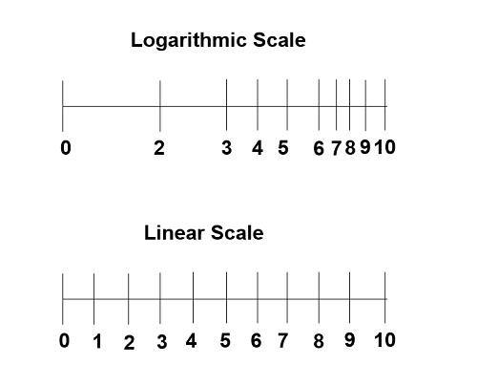
magnitude
The size or absolute value of a number. For example, $$+$$4 and $$-$$4 have a magnitude of 4.
Extended in Mathematics Extension 1 and Mathematics Extension 2: For a vector, the magnitude is its length, given by $$\left|xi+yj\right|=\sqrt{x^{2}+y^{2}}$$ for 2D vectors and $$\left|xi+yj+zk\right|=\sqrt{x^{2}+y^{2}+z^{2}}$$ for 3D vectors.
mass
The amount of matter in an object.
mean
The sum of values in a dataset divided by the total number of values in the dataset. Also called the average.
measure of centre
A statistic that is used to summarise a dataset. There are 3 common measures of centre for a dataset: mode, median and mean.
measure of spread
In statistics, different methods of calculating the variability of a set. The most commonly used measures of spread are the range, interquartile range and standard deviation.
median
The value in a set of ordered data that divides the data into 2 parts. It is frequently called the 'middle value'.
Extended in Mathematics Standard and Advanced: If the number of values in the ordered dataset is even, it is the average of the two middle values. If the number of values in the dataset is odd, the median is the middle value.
midpoint
A point on a line segment or interval that divides the segment into 2 equal parts.
Let $$\left(x_{1},y_{1}\right)$$ and $$\left(x_{2},y_{2}\right)$$ be points in the Cartesian plane. Then the midpoint $$M$$ of line segment $$AB$$ has coordinates $$\left(\frac{x_{1}+x_{2}}{2},\frac{y_{1}+y_{2}}{2}\right)$$.
This can be seen from the congruent triangles below.
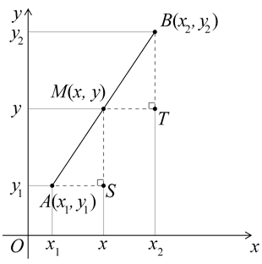
mode
The most frequently occurring value in a set of data.
Extended in 7–10: There can be more than one mode. When there are 2 modes, the dataset is said to be bimodal.
monic
A polynomial in which the coefficient of the leading term is 1.
multiples
Products formed using the same base number multiplied by different whole numbers, e.g. 3, 6, 9, 12 …
multiplicity (of a root/zero)
The number of times a particular number is a zero for a given polynomial or a root for a polynomial equation.
mutually exclusive events
Two events that cannot have simultaneous outcomes in the same chance experiment. For example, when a fair coin is tossed twice, the events 'HH' and 'TT' cannot occur at the same time and are, therefore, mutually exclusive.
In a Venn diagram, as shown below, mutually exclusive events do not overlap.
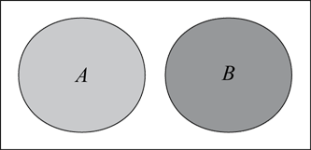
Extended in Mathematics Advanced: For a random experiment two events $$A$$ and $$B$$ are mutually exclusive if $$A∩B=∅$$ , that is, they cannot occur simultaneously.
net
A diagram showing the pattern of connected faces and the edges of an unfolded polyhedron (a solid with all faces polygons).
One possible net for a cube is shown below.
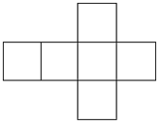
network
A set of points (vertices or nodes) some of which are joined by lines or curves (edges) that sometimes enclose regions (faces). For example, road networks, a family tree or the edges lining a tennis court.
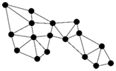
non-linear
Functions or graphs that cannot be represented by a straight line or a linear function.
number bonds
Combinations (pairs) of numbers that add to a given number, e.g. 8 + 2, 6 + 4, and 7 + 3 all bond to form 10.
number chart
A table that lists numbers in numerical order. There are different types of number charts.
For example:
- a 1–120 or 0–99 chart
- a calendar display for a month.
number line
A number line is used to represent numbers according to their distance from a zero point. The representation of a number line can start and end on any number.
number sentence
A number sentence uses numerals and mathematical symbols. A number sentence may be used instead of the word equation. For example, instead of writing 6 apples plus 7 apples equals 13 apples, the number sentence would be 6 + 7 = 13.
numerator
In the fraction $$\frac{a}{b}$$, $$a$$ is the numerator. If an object is divided into $$b$$ equal parts, then the fraction $$\frac{a}{b}$$ represents $$a$$ of these parts all together. For example, if a line segment is divided into 5 equal parts, each of these parts is one-fifth ($$\frac{1}{5}$$) of the whole and 3 of these parts taken together corresponds to the fraction $$\frac{3}{5}$$.
numerical variable
Variables whose values are numbers and for which arithmetic processes, such as adding and subtracting or calculating an average, make sense.
A discrete numerical variable is a numerical variable, each of whose possible values is separated from the next by a definite 'gap'. The most common numerical variables have the counting numbers 0, 1, 2, 3, … as possible values. Others are prices, measured in dollars and cents. For example, the number of children in a family or the number of days in a month.
object
A three-dimensional solid.
obtuse angle
An angle bigger than a right angle (90°) but smaller than a straight angle (2 right angles, or 180°).
one-to-one data display
Display of data using objects and pictures where one object or picture represents one data value.
operation
The process of combining numbers or expressions. Operations are arithmetic – addition, subtraction, multiplication and division – and also include exponentiation and substitution.
origin
The point of intersection of the $$x$$- and $$y$$-axes on the Cartesian plane.
outcome
Possible result from an experiment or trial.
outlier
A data value that appears to stand out from the other members of the dataset by being unusually high or low.
parabola
The graph of $$y=x^{2}$$. The point $$\left(0,0\right)$$ is called the vertex of the parabola and the $$y$$-axis is the axis of symmetry of the parabola.
Some other parabolas are the graphs of $$y={ax}^{2}+bx+c$$ where $$a≠0$$.
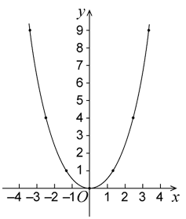
parallel
Two distinct lines, rays or line segments in the same plane that have no points of intersection and so necessarily have the same gradient (slope).
The symbol $$∥$$ is used to express that one line, ray, or line segment is parallel to another.
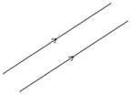
partition
Partitioning is dividing a quantity into parts.
In the early years, it commonly refers to treating whole numbers as made up of 2 parts (number bonds), e.g. 10 is 8 and 2.
In later years, it refers to dividing both continuous and discrete quantities into equal parts (equi-partitioning) when learning about fraction and division concepts.
path (networks)
A sequence of consecutive edges in a graph. The length of the path is the number of edges traversed.
pattern
A pattern is made up of a number of elements that repeat or follow a rule.
pentagon
A polygon with 5 sides.
See polygon
percentage error
The absolute error of a measurement expressed as a percentage of the recorded measurement.
perpendicular
Two lines, rays, line segments, vectors, planes or other objects that intersect at a 90° angle (a right angle).
pi
The ratio of the circumference of any circle to its diameter. It is denoted by the Greek letter $$π$$ (pi). Approximate values are $$3.14$$ or $$\frac{22}{7}$$.
picture graph
Display of data using images, symbols or pictures to represent data in categories.
piecework
Employment where a worker is paid a fixed rate for each item produced or action performed regardless of the time taken.
place value system
The place value system has 4 properties: positional, base-ten, additive and multiplicative.
The value of a digit is determined by its position in a number relative to the ones (or units) place. For example, in the number 924, the 4 denotes 4 ones, the 2 denotes 2 tens or 20 ones, and the 9 denotes 9 hundreds, 90 tens or 900 ones.
planar graph
A connected graph that is drawn within a plane whose edges do not cross.
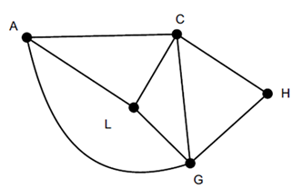
point
Representation of a location in space that has zero dimensions. Lines, curves, shapes, surfaces and objects are constructed from sets of points. Points in the Cartesian plane are specified by coordinates.
polygon
Plane shape bounded by 3 or more line segments.
polynomial
An expression made up of non-negative integer powers of the same variable and coefficients combined using addition, subtraction and multiplication.
population
The complete set of individuals, objects, places, etc., that we want information about.
Extended in Mathematics Standard and Mathematics Extension 1: In statistics it is the entire dataset from which a statistical sample may be drawn.
prime factor
A prime factor of a natural number $$n$$ is a factor of $$n$$ that is a prime number. For example, the prime factors of 330 are 2, 3, 5 and 11.
principal
The total amount of money borrowed or invested on which interest is calculated. Also referred to as present value ($$PV$$).
probability
The chance of something happening shown on a scale from 0 and 1 (inclusive). For example, the probability that a fair coin toss will come up ‘heads’ is 0.5.
pronumeral
A letter or symbol that is used to represent a value in a problem that can vary or change. Also known as a variable.
proof
A rigorous mathematical argument that demonstrates the truth of a given statement or proposition. A mathematical statement that has been established by means of a proof is called a theorem.
proportion
A constant ratio between corresponding elements of 2 sets. For example, the circumference and diameter of a circle are in proportion as their ratio is the constant $$π$$ (pi).
Pythagoras' theorem
The square of the length of the hypotenuse, $$c$$, of a right-angled triangle equals the sum of the squares of the lengths of the other 2 sides, $$a$$ and $$b$$, such that $$c^{2}=a^{2}+b^{2}$$.
quadratic equation
An equation of the form $$ax^{2}+bx+c=0$$, where $$a≠0$$, $$b$$ and $$c$$ are constants.
quadratic expression
An expression of the form $$ax^{2}+bx+c$$, where $$a≠0$$, $$b$$ and $$c$$ are constants.
quadratic formula
The roots of a quadratic equation $${ax}^{2}+bx+c=0$$ where $$a≠0$$ are given by the quadratic formula:
$$x=\frac{-b±\sqrt{b^{2} - 4ac}}{2a}$$.
quantity value
The amount a digit represents in a number. For example, the quantity value of the five in 546 is 500, and the quantity value of the four is 40.
quartiles
The values that divide an ordered dataset into 4 (approximately) equal parts. There are 3 quartiles. The first, the lower quartile $$\left(Q_{1}\right)$$, divides off (approximately) the lower 25% of data values. The second quartile $$\left(Q_{2}\right)$$ is the median. The third quartile, the upper quartile $$\left(Q_{3}\right)$$, divides off (approximately) the upper 25% of data values.
quotient
The result of dividing one number or algebraic expression by another.
radius
The distance from the centre of a circle to any point on its perimeter. It is equal to half of the circle’s diameter.
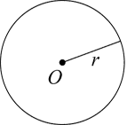
random number
A number whose value is governed by chance. For example, the number of dots showing when a fair die is tossed. The value of a random number cannot be predicted in advance.
range (function)
The set of values of the dependent variable for which a function is defined.
range (of a dataset)
The difference between the highest and lowest values in a dataset.
ratio
A comparison of magnitudes of sets, quantities of the same kind, or algebraic expressions. It is often used as a comparison $$a∶b$$ of the size of 2 (or more) quantities relative to each other.
rational number
An element of the infinite set of numbers $$Q=$$ {$$\frac{m}{n}$$, where $$m$$ and $$n$$ are integers and $$n$$ $$≠$$ 0}. It may be expressed in decimal form, e.g. $$\frac{1}{8}=0.125$$and $$\frac{4}{9}=0.444…$$
ray
The part of a line that starts at a point and continues in a particular direction to infinity.
reciprocal
If $$x$$ is any real number, then the reciprocal of that number will be $$\frac{1}{x}$$. For example, the reciprocal of 4 is $$\frac{1}{4}$$.
rectangle
A four-sided shape (quadrilateral) with opposite sides of equal length and all 4 interior angles equal (right angles).
recurring decimal
A decimal expansion of a number that contains a finite sequence of digits that repeats indefinitely, such as $$34.271271271…$$ The repeating sequence is often designated by a bar over it, such as $$34.271$$. Every recurring decimal is the decimal expansion of a rational number.
reflection
A transformation of a shape formed by creating a mirror image on the other side of a given line.
reflex angle
An angle that measures between 180 and 360 degrees, i.e. between 2 and 4 right angles.
regular shape
A two-dimensional polygon with all sides and all interior angles equal. A square is an example of a regular shape.
relation
An association between the elements of one set, $$A$$, and the elements of another set, $$B$$. It may be represented as a set of ordered pairs $$(a,b)$$, where $$a$$ is in $$A$$, $$b$$ is in $$B$$ and $$b$$ is related to $$a$$.
relative frequency
Given by the ratio $$\frac{f}{n}$$, where $$f$$ is the frequency of occurrence of a particular data value or group of data values in a dataset, and $$n$$ is the number of data values in the dataset.
remainder
The part 'left over' when dividing a number into equal groups. The remainder forms part of the next group.
Extended in 7–10: The amount left over when one number or algebraic quantity $$a$$ is divided by another $$b$$. If $$a$$ is divisible by $$b$$, then the remainder is 0. For example, when 68 is divided by 11, the remainder is 2, because 68 can be expressed as $$68=6×11+2$$.
Extended in Mathematics Extension 1: What is left over after a division. When division of a polynomial $$P(x)$$ by a non-zero polynomial $$Q(x)$$ gives $$P(x)=A(x)Q(x)+R(x)$$, where the degree of $$R(x)$$ is less than the degree of $$Q(x)$$, then $$R(x)$$ is the remainder.
repeated addition
An early strategy for solving multiplication problems used to add groups of the same quantity. For example, 3 + 3 + 3 + 3 to solve 4 groups of 3.
rhythmic counting
Rhythmic counting refers to the repeated sound pattern that students may use to vocalise the count – creating a beat to emphasise the pattern.
rounding
The process for approximating a value that lies between 2 known values. It is used to specify a number correct to a given accuracy. For example, 4.027 becomes 4.03 when rounded to 2 decimal places.
sample
A subset of a population used to estimate characteristics of the population. For example, a randomly selected group of 8-year-olds (sample) selected to estimate the height of 8-year-olds in Australia (population).
sample space
The set of all possible outcomes of a chance experiment. For example, the set of outcomes (also called sample points) from tossing 2 identical coins at the same time is {HH, HT, TT}, where H represents a ‘head’ and T a ‘tail’.
scatter plot
A visual representation of bivariate numerical data using the position of each dot on the horizontal and vertical axis to indicate the numerical values for an individual data point. Scatter plots are used to observe relationships between variables.
scientific notation
A way of writing numbers that are too big or too small to be written in an accessible way. It uses powers of 10. For example, the scientific notation for 34 590 is $$3.459×{10}^{4}$$.
secant
The straight line passing through 2 points on the graph of a function.
sector
The plane figure enclosed by 2 radii or a circle and the arc between them.
segment
A plane figure enclosed by a chord and the arc joining the endpoints of a chord.
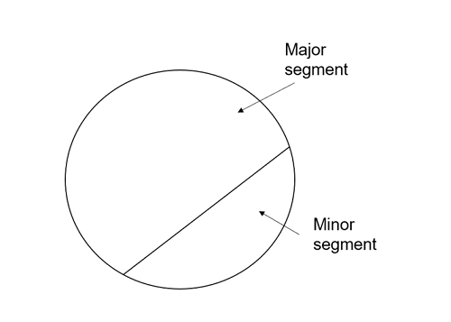
set
A collection of objects or elements, usually specified by listing its elements, e.g. $$\{1,2,3,4\}$$; by describing it in words, e.g. ‘the set of primes’; or by using a rule such as $$\{(x,y):y=2x+1,x∈N\}$$.
Extended in Mathematics Advanced, Extension 1 and Extension 2: A collection of distinct, unordered objects, referred to as members or elements of the set.
shape
A two-dimensional closed figure.
sharing division
Sharing (partitive) division requires finding how many are in each group, eg if 12 marbles are shared between 3 students, how many does each student get?
When sharing, the quotient represents the quantity of shared objects in each group.
side
A side is the line segment joining 2 vertices of a two-dimensional shape.
significant figures
Each of the digits of a number that are used to express it to the required degree of accuracy, starting from the first non-zero digit. For example, $$0.000034=3.4×{10}^{-5}$$ has 2 significant figures and when 123,456 is rounded to 3 significant figures, the result will be 123 000.
similarity
When the enlargement of one figure is congruent to another figure. Similar figures have corresponding lengths in the same proportion, are the same shape and have equal corresponding angles.
simple interest
The interest accumulated when the interest payment in each period is a fixed percentage of the principal (the initial lump sum of money).
The simple interest formula is given by $$I=PRn$$ where $$I$$ is the interest earned, $$P$$ is the principal value invested, $$R$$ is the rate of interest and $$n$$ is the number of time periods over which the interest is applied.
simulation
A recreation of random phenomena used to collect probability data through either physical or virtual manipulatives such as spinners, coins and cards or computer-generated simulations that can be performed a large number of times.
simultaneous equations
A set of 2 or more equations, each containing 2 or more variables whose values can simultaneously satisfy all the equations in the set, the number of variables being equal to or less than the number of equations in the set.
sine ratio
In any right-angled triangle, $$\sin{θ=\frac{\text{opposite}}{\text{hypotenuse}}}$$ where $$0^{°}<θ<{90}^{°}$$.

skewness
A measure of asymmetry (non-symmetry) in a distribution of values about the mean of a set of data.
skip counting
Skip counting is counting forwards or backwards in groups or multiples of a particular number, e.g. 5, 10, 15, 20 ...
slide (translation)
Sliding a shape without turning it.
square
A four-sided shape (quadrilateral and a parallelogram) with all sides of equal length and all 4 interior angles equal (right angles).
square numbers
The result of multiplying a natural number by itself. For example, $$16=4×4=4^{2}$$, and is an element of the set $$\{0, 1, 4, 9, 16, 25 ...\}.$$
square root
A value that when multiplied by itself gives the original number. The positive square root of a given real number $$x$$ is the positive real number $$y$$ such that $$y^{2}=x$$.
standard deviation
A measure of the variability or spread of a dataset. It gives an indication of the degree to which the individual data values are spread around their mean.
Extended in Mathematics Standard and Advanced: For a random variable, the standard deviation is the square root of its variance.
It provides a measure of the spread of the probability density function.
stem-and-leaf plot
A method of organising and displaying numerical data in which each data value is split into 2 parts, a 'stem' and a 'leaf'. For example, the stem-and-leaf plot below displays the resting pulse rates of 19 students. The stem is on the left side of the vertical line and the leaves are on the right side.
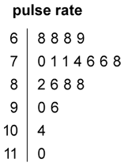
See back-to-back stem-and-leaf plot
subtend
In geometry, an angle subtended by an arc or interval is the angle whose 2 rays pass through the endpoints of the arc or interval. A possible synonym for ‘subtends’ is ‘makes’.
superimposed
To place or lay on top of.
supplementary angles
Two adjacent angles that form a straight angle and whose sum is 180 degrees (a straight angle). For example, 45° and 135° are supplementary angles.
surd
A numerical expression involving one or more irrational roots of numbers.
Extended in Mathematics Advanced: An irrational root of a number, e.g. $$\sqrt{5}$$ and $$\sqrt[3]{4}$$.
More generally sums involving rational multiples of surds are sometimes also referred to as surds, e.g. $$2+\frac{3\sqrt{7}}{4}$$.
surface
The flat or curved area of an object. A surface with straight edges is called a face, a surface with a curved boundary is called a curved surface.
See face
surface area
The measure of the total area of the surface(s) of a three-dimensional shape or object. For example, the surface area of a cube with side length of 5 units is 150 square units.
symmetrical distribution
When the 2 sides of the distribution are a mirror image of each other. A normal distribution is a true symmetric distribution of observed values.
table
An arrangement of information in rows and columns.
tangent
A line that intersects a circle at just one point. It touches the circle at that point of contact but does not pass inside it.
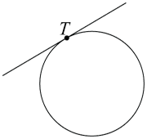
Extended in Mathematics Advanced, Extension 1 and Extension 2: For a curve at a given point $$P$$ the tangent can be described intuitively as the straight line that ‘just touches’ the curve at that point. At $$P$$ the curve has ‘the same direction’ as the tangent. In this sense, it is the best straight-line approximation to the curve at point $$P$$. For a differentiable function $$f(x)$$ the tangent to its graph at the point $$P\left(a,f\left(a\right)\right)$$ has slope $$f'(a)$$.
tangent ratio
The ratio of the length of the altitude, $$a$$, of a right-angled triangle to the length of its base, $$b$$, for a given base angle, theta, $$θ$$.
In any right-angled triangle, $$\tan{θ=\frac{\text{opposite}}{\text{adjacent}}}$$, where $$0$$° $$<θ<$$ $$90$$°.
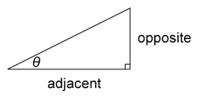
taxable income
The amount of yearly income that is used to calculate an individual’s or company’s payable income tax.
terminating decimal
A decimal expansion of a number that has a finite number of non-zero digits, e.g. 3.125. Every terminating decimal represents a rational number where the denominator is a power of 10.
trail (networks)
A walk where no edges are repeated.
transversal
A line that intersects 2 other lines obliquely.
tree diagram
A diagram consisting of line segments (edges) connected to points (vertices) like the branches of a tree. It shows the relationship between sets, events or the set of outcomes of a multi-step random experiment.
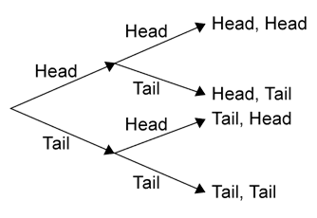
See probability tree
triangle
A closed shape with exactly 3 straight sides and 3 interior angles.
trigonometric ratios
The relationship between the angles and sides of right-angled triangles. The 3 basic trigonometric ratios are sine, cosine and tangent.
See sine ratio, cosine ratio and tangent ratio
true bearing
Measured in degrees clockwise from true north and written with 3 digits to specify the direction. For example, the direction of north is specified as $$000$$°T, east is specified as $$090$$°T, south is specified as $$180$$°T and north-west is specified as $$315$$°T.
two-dimensional
Having length and width only (with no depth).
two-way table
A common way of displaying the two-way frequency distribution that arises when a group is categorised according to 2 criteria.
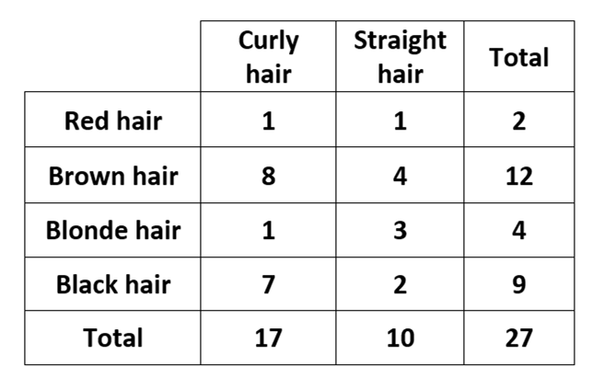
uniform
Means ‘the same as’. Used to refer to units of the same size used for measuring.
unit circle
A circle with a radius of 1 unit.
variable (algebra)
Things that are measurable or observable that are expected to either change over time or between individual observations. They are often designated by symbols, such as $$n$$, $$x$$ and $$y$$, to represent members of a set. For example, the variable $$x$$ could represent an unspecified real number.
variable (statistics)
Something measurable or observable that is expected to change either over time or between individual observations. For example, the age of students, their hair colour or a playing field's length or its shape.
Venn diagram
Graphical representations, using several typically overlapping circles, showing elements of sets in relation to properties or attributes. They are drawn for some specified universal set.
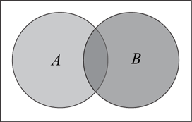
vertex
Where 2 straight sides of a two-dimensional shape meet.
Extended in 7–12: A vertex is a point in the plane where lines meet and do not extend beyond, or a point in space where several edges meet. A vertex can also refer to a node in a network. It is also the turning point of a parabola.
vertical line test
Determines whether a relation or graph is also a function. If a vertical line intersects or touches a graph at more than one point, then the graph is not a function.
vertically opposite angles
Two pairs of vertically opposite angles formed at the point of intersection of 2 lines in a plane. Vertically opposite angles are equal.
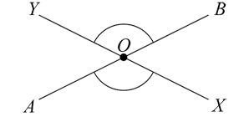
volume
The amount of space occupied by an object.
walk (networks)
A sequence of edges and vertices in a network.
weight
The measure of the force of gravity acting on a body with a given mass. An object can be weightless without its mass being zero. The term ‘weight’ is used as a synonym for mass when the concept of gravitational force has not been introduced.

Global Terms
Aboriginal and Torres Strait Islander Peoples
Aboriginal Peoples are the first peoples of Australia and are represented by more than 250 language groups, each associated with a particular Country or territory. Torres Strait Islander Peoples are represented by 5 major island groups, and are associated with island territories to the north of Australia’s Cape York which were annexed by Queensland in 1879.
An Aboriginal and/or Torres Strait Islander person is someone who:
- is of Aboriginal and/or Torres Strait Islander descent
- identifies as an Aboriginal person and/or Torres Strait Islander person, and
- is accepted as such by the Aboriginal and/or Torres Strait Islander community(ies) in which they live.
Aboriginal English
A recognised dialect of English which is the first, or home language, of many Aboriginal people. It differs from other dialects of English, such as Standard Australian English, in systematic ways including sounds, grammar, words and their meanings, and language use. Aboriginal English is a powerful vehicle for the expression of Aboriginal identity. Aboriginal English is not a target language study option for NSW Aboriginal Languages syllabuses.
Aboriginal Songline(s)
Texts that describe landscapes and directions of the tracks forged in lands, waters and skies by Creator Spirits during the Dreaming.
accessibility
The extent to which a system, environment or object may be used irrespective of a user’s capabilities or abilities. For example, the use of assistive technologies (AT) to allow people with disability to use computer systems, or the use of icons in place of words to allow young children to use a system.
assistive technology (AT)
A device or system whose primary purpose is to maintain or improve an individual's functioning and independence to facilitate participation and enhance overall wellbeing. This includes technologies specifically designed to meet an individual's needs, eg eye gaze technology, as well as more general technologies that can be used by anyone, eg speech-to-text applications. Assistive technology can also be referred to as inclusive technology.
augmentative and alternative communication (AAC)
An umbrella term that encompasses the communication methods used to supplement or replace speech or writing. AAC can be unaided, such as gestures, body language and sign language, or aided such as pictures, symbols, objects or speech generating devices.
See communication systems
communication forms
The ways people communicate and the communicative behaviours they use. Communication forms can be non-symbolic and/or symbolic. Non-symbolic forms include sounds, gestures, facial expressions and eye movements. Symbolic forms can be aided or non-aided. Aided forms of symbolic communication include objects, symbols, photographs and drawings. Aided forms can be digital. Non-aided forms of symbolic communication include formal gestures; speech; and signs, such as Key Word Sign.
copyright
The protection provided to the creators of original works and makers of sound recordings and films, that offers a legal framework for the control and reproduction or transmission of their literary, dramatic, artistic or musical works.
Country/Place
Country is used to describe a specific area of a nation or clan including physical, linguistic and spiritual features. Aboriginal communities’ cultural associations with their Country may include or relate to languages, cultural practices, knowledge, songs, stories, art, paths, landforms, flora, fauna and minerals. These cultural associations may include custodial relationships with particular landscapes such as land, sea, sky, rivers as well as the intangible places associated with the Dreaming(s). Custodial relationships are extremely important in determining who may have the capacity to authentically speak for their Country.
Place is a space mapped out by physical or intangible boundaries that individuals or groups of Torres Strait Islander Peoples occupy and regard as their own. It is a space with varying degrees of spirituality.
culture
The customs, habits, beliefs/spirituality, social organisation and ways of life that characterise different groups and communities. Cultural characteristics give a group or individual a sense of who they are and help them make sense of the world in which they live. Culture is a shared system but inherently diverse – there can be individual and group differences within cultures. Everyone has culture – it is a lens through which we see the world.
custodians
In Aboriginal communities, an individual charged with maintaining and passing on particular elements of cultural significance, eg language, stories, songs, rituals and imagery.
See owners
d/Deaf
When referring to deaf people who belong to a linguistic and cultural minority known as the Deaf community, the 'D' may be capitalised in reference to the individual, the group, or the culture in order to accord respect and deference, for example, the Deaf community. When referring simply to audiological status or when cultural affiliation is not known, as in the case of a person with a hearing loss in general, the lowercase 'd', as in 'deaf' is the more common usage.
Deaf
A cultural identity for people with hearing loss who share a common culture and who usually have a shared sign language.
disability
An umbrella term for any or all of the following components:
- impairments: challenges in body function or structure
- activity limitations: difficulties in executing activities
- participation restrictions: challenges an individual may experience in involvement in life situations. (World Health Organization)
diversity
Differences that exist within a group, for example, age, sex, gender, gender expression, sexuality, ethnicity, ability/disability, body shape and composition, culture, religion/spirituality, learning differences, socioeconomic background, values and experiences.
Dreaming
The Dreaming has different meanings for different Aboriginal groups. The Dreaming can be seen as the embodiment of Aboriginal creation which gives meaning to everything; the essence of Aboriginal beliefs about creation and spiritual and physical existence. It establishes the rules governing relationships between the people, the land and all things for Aboriginal Peoples. The Dreaming is linked to the past, the present and the future. Where appropriate, refer to Aboriginal names for the Dreaming.
Elders
The custodians of knowledge and lore. They are chosen and accepted by their own communities as people who have the permission to disclose cultural knowledge and beliefs. Recognised Elders are highly respected people within Aboriginal communities. Proper consultation with local Aboriginal communities will often direct schools to recognised Elders.
first language(s)
The first language(s) that a person learns to speak.
Indigenous
An internationally recognised term for the first peoples of a land. In NSW the term Aboriginal person/Peoples is preferred.
See Aboriginal and Torres Strait Islander Peoples
Indigenous cultural and intellectual property (ICIP)
Includes, but is not limited to, objects, sites, cultural knowledge, cultural expression and the arts, that have been transmitted or continue to be transmitted through generations as belonging to a particular Indigenous group or Indigenous people as a whole or their territory.
See intellectual property
intellectual property
Non-material assets such as forms of cultural expression that belong to a particular individual or community. Intellectual property rights refer to the rights that the law grants to individuals for the protection of creative, intellectual, scientific and industrial activity, such as inventions.
See Indigenous cultural and intellectual property (ICIP), and copyright
Key Word Sign
A communication strategy that incorporates signing with speech. It is used to support language development for people with communication difficulties. Although Key Word Sign uses a simplified form of manual signing, it is different to Auslan, as it is not a signed language.
kinship
A key aspect of Aboriginal cultures and values. It includes the importance of all relationships and of being related to and belonging to the land.
language group
An Aboriginal community identified with a common language, both verbal and nonverbal, and with a particular territory. Used in preference to the term ‘tribe’.
language revival
The process and range of strategies for increasing knowledge and use of a language that is no longer spoken fluently across all generations in the context of language loss or language dispossession caused by colonisation. Aboriginal Languages and Torres Strait Islander Languages are being revived through community initiatives, linguistic research and school programs. ‘Language revival’ may be used as an overarching term that could also include ‘reclamation’, ‘revitalisation’, ‘renewal’ and ‘reawakening’.
local Aboriginal community
A local Aboriginal community is constituted by those people who are Aboriginal and who reside in the near locality. Aboriginal communities will have a rich and diverse history that has been seriously affected by dispossession and relations, which sees families with spiritual connection to Country residing beside those who have been forced to move from other locations. The notion of locality is complex and multilayered: schools should seek advice from a range of people and/or organisations representing local interests.
See community(ies)
off-Country
Taking place away from Aboriginal land or Country of origin.
See Country/Place
on-Country
Taking place on Aboriginal land or Country of origin.
See Country/Place
owners
Each Aboriginal Language is recognised as belonging to a particular geographical area and thus to the people who can claim a connection to that area. Aboriginal community members acquire ownership of their language(s) at birth. Language proficiency is not essential for ownership.
See custodians
protocols
The appropriate ways of behaving, communicating and showing respect for diversity of history and culture. This involves appreciation of the knowledge, standing and status of people within the local Aboriginal community and the school community. Protocols inevitably vary between communities, and between people within a community. In establishing a partnership between schools and Aboriginal communities, it is especially important that protocols are acknowledged and respected.
respect
A term used commonly in NSW Aboriginal communities to refer to the way an individual treats others. Showing respect occurs in many ways, such as waiting to speak, listening and demonstrating understanding, not asking too many direct questions, ensuring that people are not made to feel uncomfortable or uneasy, and generally showing regard for others’ ideas, beliefs and culture.
sign
Hand signs (or hand talk) used to supplement or replace oral language. Signs form part of nonverbal communication for Aboriginal and Torres Strait Islander Peoples and may be used by people who are hearing, or d/Deaf or hard of hearing. Aboriginal and Torres Strait Islander Sign Languages may be used in some areas. Some Sign Languages may be associated with sacred ceremonial practices.
signage
The use of words, graphic designs and/or symbols used to communicate a message, eg information signs, plaques, warning signs, road signs, signs that show direction.
switch
A type of assistive technology that enables people with cognitive and/or physical disability to access a range of devices, including computers and communication devices. Switches can be activated by touch, or triggered without contact, such as through eye gaze, sound or blowing.
See assistive technology (AT)
yarning circle
Yarning circles are an important cultural practice for Aboriginal and Torres Strait Islander Peoples to learn within the collective group. Knowledge and information are shared in harmony and respect with all individuals.

